**Realms of Mastery**

**Defense Report**

**Date:** 04/17/2024

**Developed By:** Alena Durel

**Major:** Computer Science and Cybersecurity

**Degree:** Bachelor of Science

**Advisor:** Professor Julie Henderson

Table of Contents

Statement of Purpose 3

Research and Background 4

Motivation 4

Research 4

Project Description 5

Project Langauge(s), Software, and Hardware 5

Project Requirements 6

Functional 6

Look and Feel 8

Usability 9

Performance 10

Maintainability and Support 10

Security 11

Cultural 11

Project Implementation 11

Link to Source Code 11

Implemenation 12

Figures 13

Test Plan 29

Introduction 29

Test Items 29

Features to be Tested 30

Features Not to be Tested 31

Approach 32

Item Pass/Fail Criteria 32

Test Cases 36

Student Testing 44

Suspension Criteria and Resumption Requirements 44

Schedule 47

Staffing and Training Needs 48

Responsibilities 48

Risks 48

Assumptions and Dependencies 49

Test Results 50

Developer Testing 50

Student Testing 50

Challenges Overcome 51

Future Enhancements 52

Defense Slides 52

# Statement of Purpose

While teachers strive to educate their students in the classroom, they face challenges with keeping students engaged and actively learning. Elementary-aged children have a very limited attention span and often get bored or distracted during lessons. Thus, there is a need to develop innovative and creative solutions to engage and entertain students, while also cultivating their learning and understanding of the material. I propose an adventure style game that will provide students with a stimulating environment in which to reinforce the skills that they are taught in their lessons. This game will be aimed towards 3rd and 4th grade students and will be based on the South Carolina Academic Standards. By basing this game on the standards, it will not be taking away from time spent learning, but rather can be used as a tool to help fill the gaps and keep students engaged with the material. With the vast expansion of technology, it is important to find ways to integrate these advancements with education and use them to facilitate learning rather than hinder it.

# Research and Background

## Motivation

I have chosen to complete this project for several reasons:

1. Before deciding to major in computer science, I wanted to be an educator. Although I decided to pursue a different career, I still value education and the necessity of great teachers and tools to foster a love of learning in students. I would like to create a program that can be used to help further practice what is taught in the classroom and educate students in a stimulating and engaging format.

2. I have always wanted to develop a game, and this project will give me the opportunity to create a program that I am excited about and proud of.

3. I believe that this project will allow me to push myself further in my journey as a software developer and will be good test of the skills that I have developed over the years through academic work, personal projects, and internships.

## Research

For this project, I partnered with Ashlyn Durel, a fourth grade teacher, as my educational consult. She helped with my research efforts and ensured that I had a grasp of the standards that the game aims to achieve. She also provided suggestions and further information on how to properly create a game that can be used as a learning enrichment tool. In addition to my educational consult’s advice, I did my own research on the academic standards and other educational games in order to make this game fun while still providing value in the classroom

Additionally, I worked to gain a deeper understanding of Java and its GUI components. Doing this helped me throughout the project and ensured that I had a strong foundation to build on.

# Project Description

Realms of Mastery will be an adventure-style game that is primarily intended for use by 3rd and 4th grade students and will be based on the South Carolina Academic Standards. The student will get to choose their character and fighting style (math or ELA-based) and will travel the realm while answering a variety of questions to defeat monsters, collect some treasure, and gather achievements. This game will also feature a boss rush mode that will allow students to practice questions geared toward a specific standard that they might be struggling with.

# Project Langauge(s), Software, and Hardware

**Language**

This program was developed in Java. Some of the libraries, packages, and development kits include:

1. javax.swing.JPanel
2. javax.swing.JFrame
3. java.io.*
4. java.awt.*
5. javax.imageio.*

**Software**

Some of the software used in development and testing include:

1. Java 8
2. Java SE Development Kit 15.0.1 (JDK 15.0.1)
3. IntelliJ - IDE used to develop this program
4. Visual Studio Code - IDE used to develop this program
5. CotEditor and Notepad++ - Text editor for configuring all *.txt files used in this program
6. Piskel - Pixel art web app used to create sprites

**Hardware**

The following hardware was used for development and testing.

Macbook Pro 2019

- Intel Core i9 CPU, 8-Core @ 2.4 GHz

- Intel UHD Graphics 630 1536 MB (Built-in)

- 64 GB RAM DDR4 2667 MHz

The following hardware was used for testing.

PC, built in 2022

- AMD Ryzen 5 5600X CPU, 6-Core @ 3.7 GHz

- Radeon RX 6600 GPU, 8GB

- 32 GB RAM (2x16) DDR4 3200 MHz

Macbook Pro 2019 – Student Testing

- Intel Core i7, 6-Code @2.6 GHz

- Intel UHD Graphics 630 1536 MB (Built-in)

- 16 GB RAM DDR4 2400 MHz

# Project Requirements

## Functional

|  |  |  |  |
| --- | --- | --- | --- |
| **ID:** 01a | **Type:** Functions | **Priority:** 5 | **Originator:** Alena Durel |
| **Description:** This product will be a basic adventure style game. | | | |
| **Fit Criterion:** The user will be able to navigate the world, fight monsters, gather treasure, and collect achievements. | | | |

|  |  |  |  |
| --- | --- | --- | --- |
| **ID:** 01b | **Type:** Functions | **Priority:** 5 | **Originator:** Alena Durel |
| **Description:** This product will ask the user questions to facilitate game play. | | | |
| **Fit Criterion:** The user will need to answer questions from a variety of different standards in order to fight monsters, gain treasure, and progress through the game. | | | |

|  |  |  |  |
| --- | --- | --- | --- |
| **ID:** 01c | **Type:** Functions | **Priority:** 5 | **Originator:** Alena Durel |
| **Description:** This product will implement a character selection feature. | | | |
| **Fit Criterion:** The user will be able to customize their character. | | | |

|  |  |  |  |
| --- | --- | --- | --- |
| **ID:** 01d | **Type:** Functions | **Priority:** 5 | **Originator:** Alena Durel |
| **Description:** This product will implement a fighting style selection feature. | | | |
| **Fit Criterion:** The user will be able to select their fighting style (Math-based or ELA-based). | | | |

|  |  |  |  |
| --- | --- | --- | --- |
| **ID:** 01e | **Type:** Functions | **Priority:** 5 | **Originator:** Alena Durel |
| **Description:** This product will implement an inventory system that will keep track of a player's treasure. | | | |
| **Fit Criterion:** The user will be able to view their inventory to gain an accurate representation of the amount and variety of treasure they have. | | | |

|  |  |  |  |
| --- | --- | --- | --- |
| **ID:** 01f | **Type:** Functions | **Priority:** 4 | **Originator:** Alena Durel |
| **Description:** This product will contain an achievements page. | | | |
| **Fit Criterion:** The user will be able to view their achievements page and view trophies that will appear as they progress through the game. | | | |

|  |  |  |  |
| --- | --- | --- | --- |
| **ID:** 01g | **Type:** Functions | **Priority:** 4 | **Originator:** Alena Durel |
| **Description:** This product will implement a stats page. | | | |
| **Fit Criterion:** The user will be able to view their stats page to view info such as monsters slain, treasure found, questions answered, etc. | | | |

|  |  |  |  |
| --- | --- | --- | --- |
| **ID:** 01h | **Type:** Functions | **Priority:** 3 | **Originator:** Alena Durel |
| **Description:** This product will implement a shopping feature. | | | |
| **Fit Criterion:** The user will be able to spend the treasure that they find along the way at the shop. | | | |

|  |  |  |  |
| --- | --- | --- | --- |
| **ID:** 01i | **Type:** Functions | **Priority:** 2 | **Originator:** Alena Durel |
| **Description:** This product will implement Non-Player Characters (NPCs). | | | |
| **Fit Criterion:** The user will be able to talk to and interact with NPCs throughout the world. | | | |

|  |  |  |  |
| --- | --- | --- | --- |
| **ID:** 01j | **Type:** Functions | **Priority:** 5 | **Originator:** Alena Durel |
| **Description:** This product will implement a boss rush mode. | | | |
| **Fit Criterion:** The user will be able to choose to play a boss rush mode which will allow them to continuously fight against monsters while practicing questions for a specific standard. | | | |

## Look and Feel

|  |  |  |  |
| --- | --- | --- | --- |
| **ID:** 02 | **Type:** Appearance and Styles | **Priority:** 3 | **Originator:** Alena Durel |
| **Description:** This product's appearance shall be engaging and exciting to an elementary aged student. | | | |
| **Fit Criterion:** An average 3rd or 4th grader would find the product's appearance engaging and fun and would rate it at a 4 out of 5 on a Likert scale (1 being least engaging and 5 being the most). | | | |

## Usability

|  |  |  |  |
| --- | --- | --- | --- |
| **ID:** 03a | **Type:** Ease of Use | **Priority:** 4 | **Originator:** Alena Durel |
| **Description:** This product will be usable by people with basic computer operation skills. | | | |
| **Fit Criterion:** Someone unversed in technical computer operations will be able to easily use and navigate this program. | | | |

|  |  |  |  |
| --- | --- | --- | --- |
| **ID:** 03b | **Type:** Understandability | **Priority:** 4 | **Originator:** Alena Durel |
| **Description:** This basic functions of this program will be easily understandable to an average 3rd or 4th grade student. | | | |
| **Fit Criterion:** After completing a tutorial, a 3rd or 4th grade student will be able to play this game with minimal assistance from an adult. | | | |

|  |  |  |  |
| --- | --- | --- | --- |
| **ID:** 03c | **Type:** Personalization | **Priority:** 5 | **Originator:** Alena Durel |
| **Description:** This product will contain a feature that will allow the user to customize their character. | | | |
| **Fit Criterion:** The user will be able to choose between two base sprites (a boy and a girl) and will be able to customize the hair, skin, and shirt color of their character. | | | |

|  |  |  |  |
| --- | --- | --- | --- |
| **ID:** 03d | **Type:** Personalization | **Priority:** 5 | **Originator:** Alena Durel |
| **Description:** This product will contain a feature that will allow the user to customize their fighting style. | | | |
| **Fit Criterion:** The user will be able to choose between a Math-based or ELA-based fighting style. A Math-based fighter will get a higher percentage of math questions while an ELA-based fighter will get a higher percentage of ELA questions. | | | |

## Performance

|  |  |  |  |
| --- | --- | --- | --- |
| **ID:** 04a | **Type:** Percision or Accuracy | **Priority:** 5 | **Originator:** Alena Durel |
| **Description:** This product will accurately interpret user input and keep track of quantitative data such as a player's amount of money or stats. | | | |
| **Fit Criterion:** Key input will be interpreted correctly by the program, ie. if 'W' is pressed the player will move forward. In addition to handling key input, this program will also ensure that when quantitative data is manipulated it will not be corrupted or incorrect. | | | |

|  |  |  |  |
| --- | --- | --- | --- |
| **ID:** 04b | **Type:** Reliability and Availability | **Priority:** 2 | **Originator:** Alena Durel |
| **Description:** This product will available to the user until they exit the program. | | | |
| **Fit Criterion:** The product will only close once the user clicks the exit button. | | | |

## Maintainability and Support

|  |  |  |  |
| --- | --- | --- | --- |
| **ID:** 05a | **Type:** Maintenance Requirements | **Priority:** 2 | **Originator:** Alena Durel |
| **Description:** Bug fixes will be provided to the product as issues arrive. | | | |
| **Fit Criterion:** Bugs will be fixed and patches will be applied to the product as they are needed. | | | |

|  |  |  |  |
| --- | --- | --- | --- |
| **ID:** 05b | **Type:** Adaptability Requirements | **Priority:** 3 | **Originator:** Alena Durel |
| **Description:** This product is expected to run under Windows, MacOS, or Linux. | | | |
| **Fit Criterion:** This program will be runnable on Windows, MacOS systems, and Linux systems. | | | |

## Security

|  |  |  |  |
| --- | --- | --- | --- |
| **ID:** 06a | **Type:** Privacy Requirements | **Priority:** 5 | **Originator:** Alena Durel |
| **Description:** This product will not store PPI (Private Personal Information) data. If this is changed in a later feature update, data will be stored in a secure way. | | | |
| **Fit Criterion:** No PPI data will be stored for this product. | | | |

|  |  |  |  |
| --- | --- | --- | --- |
| **ID:** 06b | **Type:** Privacy Requirements | **Priority:** 5 | **Originator:** Alena Durel |
| **Description:** This product will notify users of changes to its information policy. | | | |
| **Fit Criterion:** Users will be informed if a feature is introduced that will collect data or change the current information policy. | | | |

## Cultural

|  |  |  |  |
| --- | --- | --- | --- |
| **ID:** 07 | **Type:** Diversity and Inclusion | **Priority:** 4 | **Originator:** Alena Durel |
| **Description:** This product will include a character customization feature that will allow the game to be more inclusive of different users. | | | |
| **Fit Criterion:** The character selection will allow the user to select things such as hair color and skin color. | | | |

# Project Implementation

## Link to Source Code

Link to source code: <https://github.com/alenanicole/CSU-Senior-Project-Realms-Of-Mastery/tree/master/src>

## 

## Implemenation

Realms of Mastery was developed in Java, utilizing the Swing and Graphics2D libraries for the GUI. I began with a basic foundation for the game to be built upon, with a simple grass backgroun and a single character. Learning the basics of creating a 2D game in Java was a very rewarding process, from getting to see the player walk across the screen or change directions at the click of a key to adding different backgrounds and objects.

From there, I began to plan out the basis for the game and the general flow of gameplay. With the help of my educational consult, I was able to determine the type of questions and gameplay that would best be suited for the target audience of 4th grade. Multiple different gameplay options are integrated into Realms Of Mastery, from diving into a dungeon run, to completing a boss rush, to wandering the world in search of Super Chests. With these different gameplay options, students are not only able to practice a variety of skills, but also target weak areas.

Moving forward from the foundation of the game, I first implemented a separate map as the dungeon. Throughout this map, monsters spawn, items are dropped, chests are placed, and there is a boss to be defeated. The primary actions in these runs are to fight monsters and collect treasure from the chests. Questions are randomly generated for each encounter based on the difficulty chosen by the player, yeilding different rewards. The primary items found here are keys to open doors, coins to spend in the shops, and potions to boost a player’s run. The potions include a health, speed, strength, and reroll potion, helping the player reach the end of the run and attaining victory.

Next, the outside of the dungeon began to take shape. Here, the player is able to visit shops and interact with Non Player Characters, purchasing weapons, upgrades, outfits, and potions. In addition to the shops, there are also Super Chests throughout the world. While these chests are much harder to open, the reward is great!

Finally, Boss Rush mode was implemented to target weak areas. A player is able to select the category that they wish to practice and choose how many questions they want to answer. At the end of their boss rush, a player will be able to see how they did.

## Figures

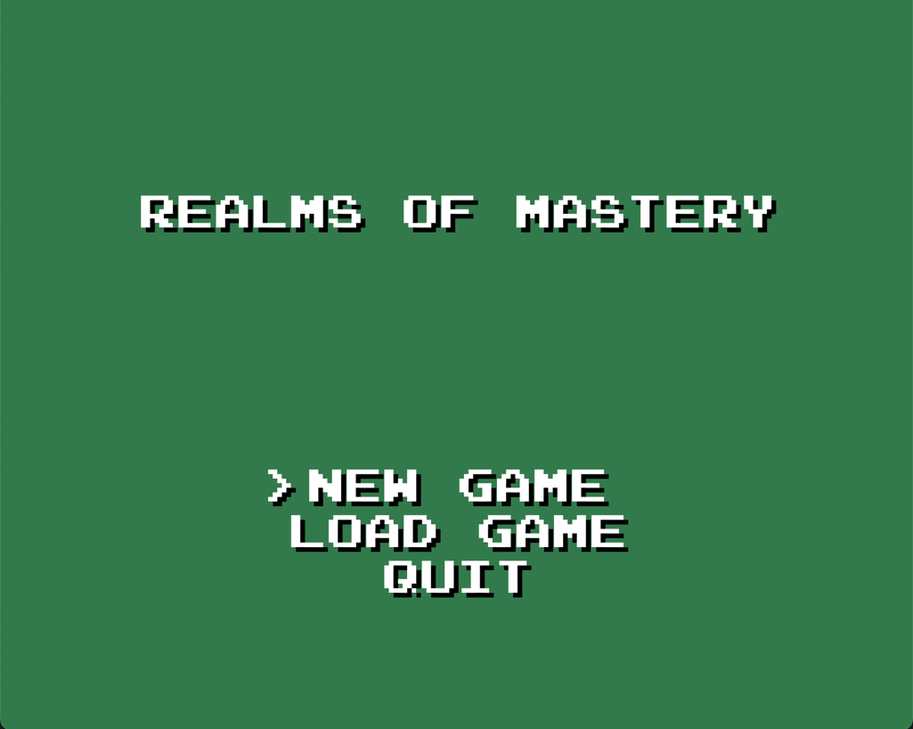

Fig 1. Realms of Mastery Title Screen

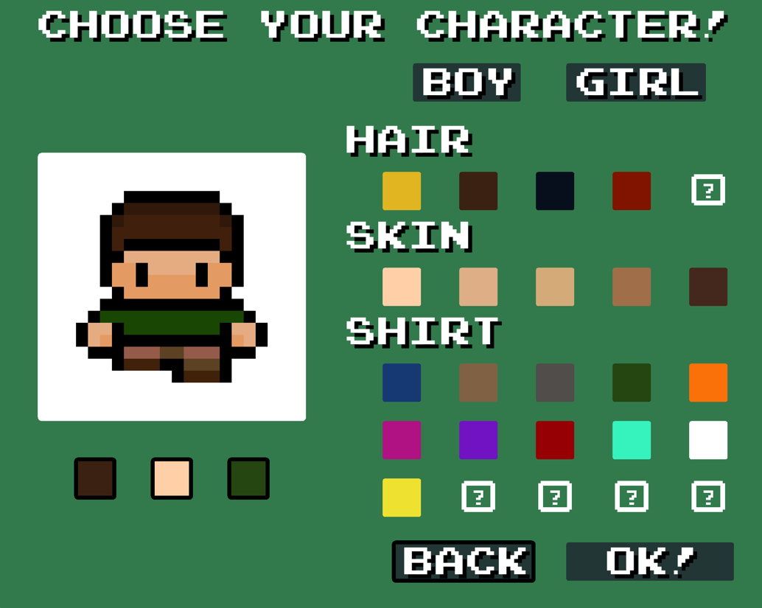

Fig 2. Character Selection Screen

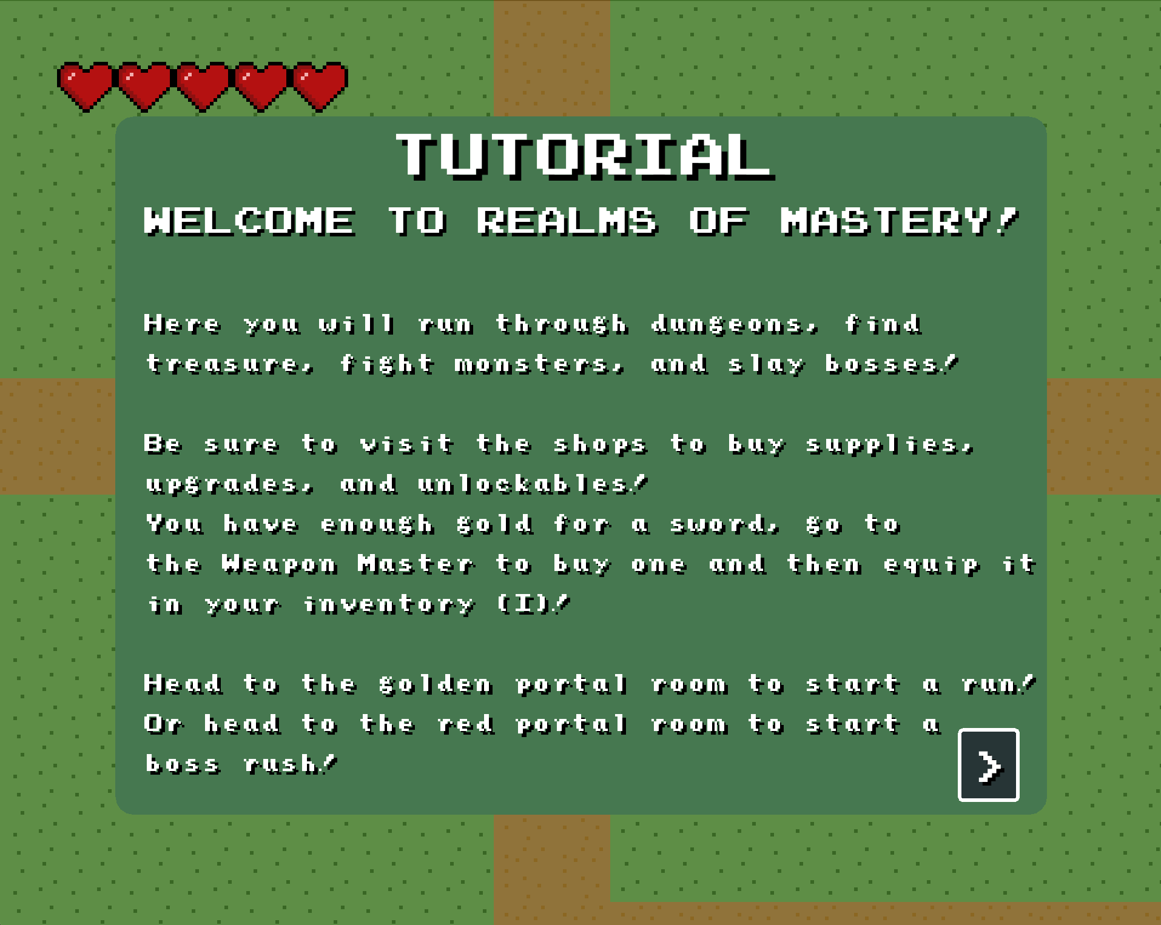

Fig 3. Tutorial Screen

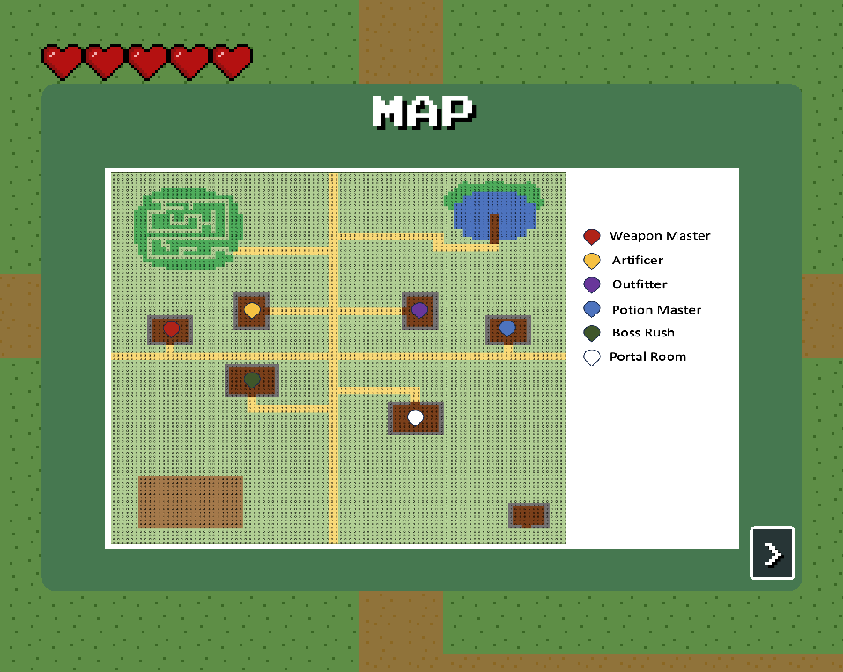

Fig 4. Map Screen

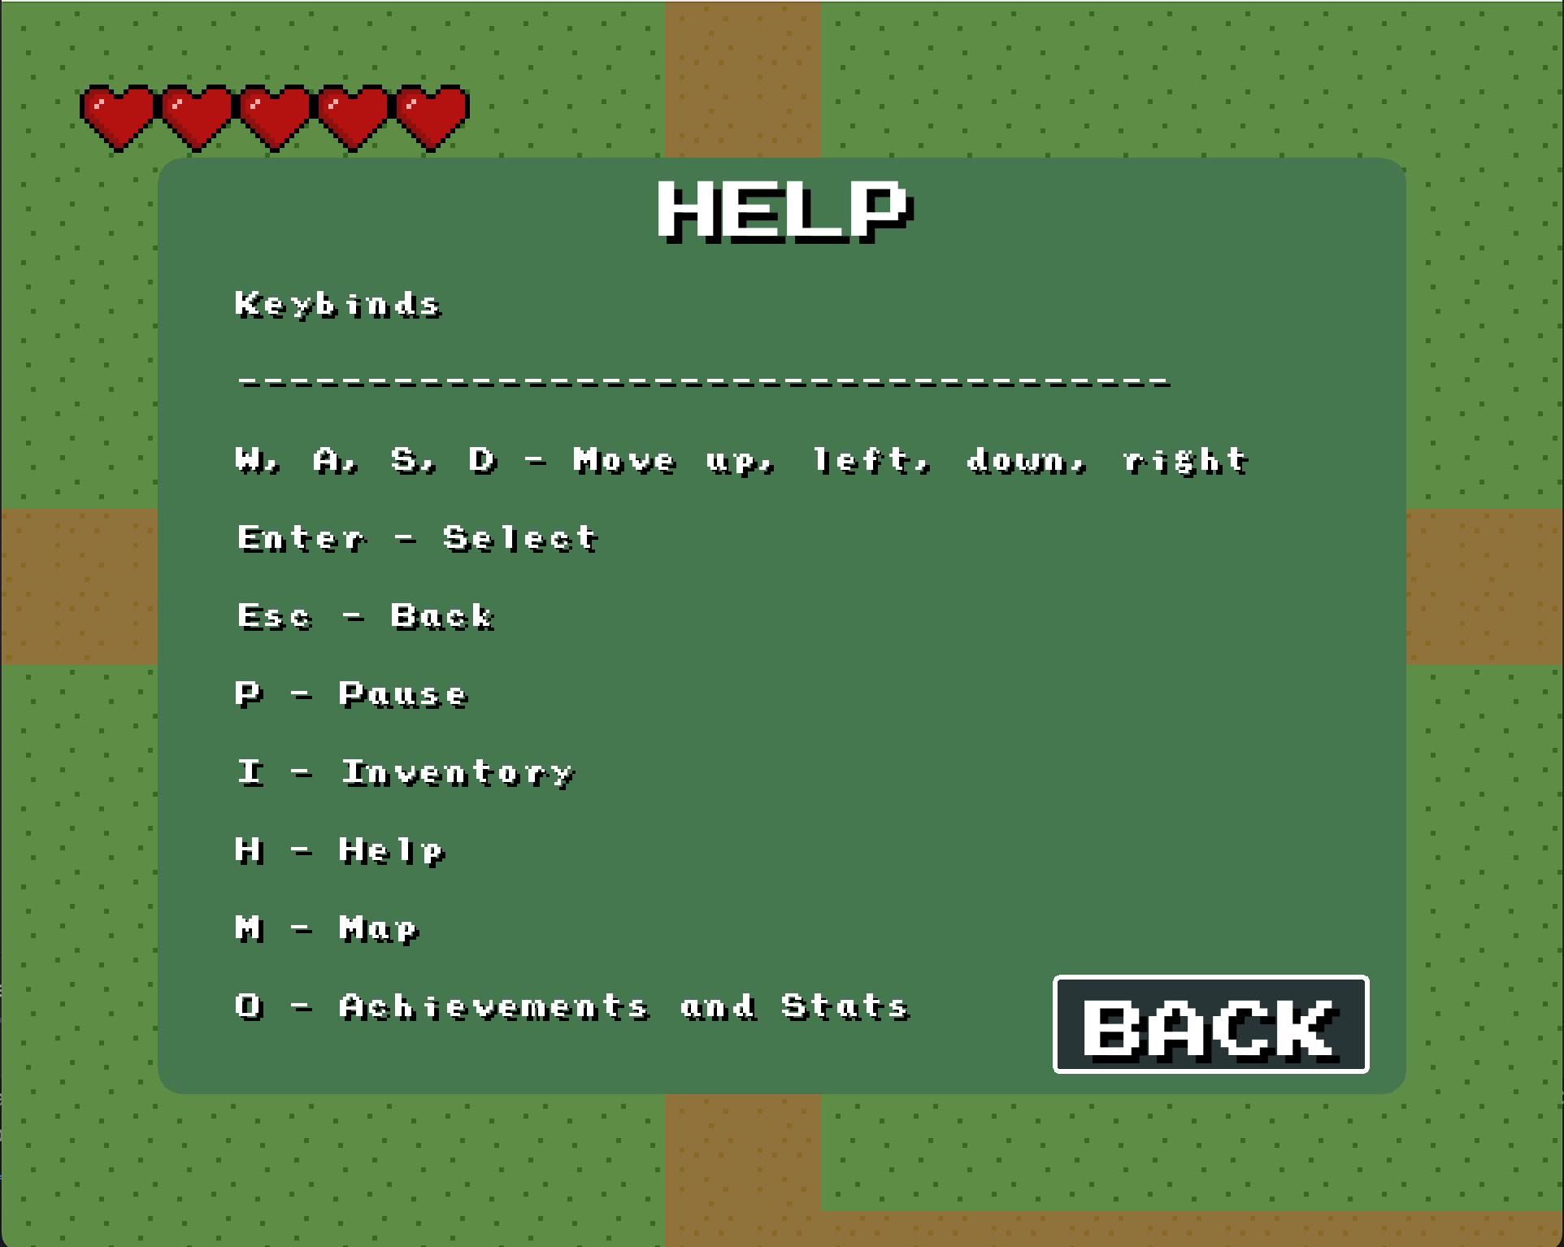

Fig 5. Help Screen

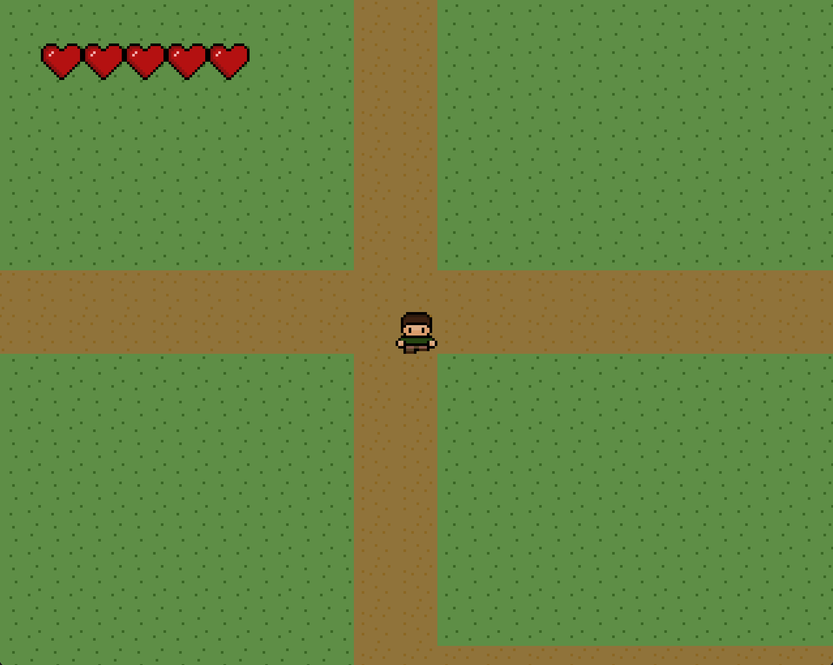

Fig 6. Character starts at the center of the map

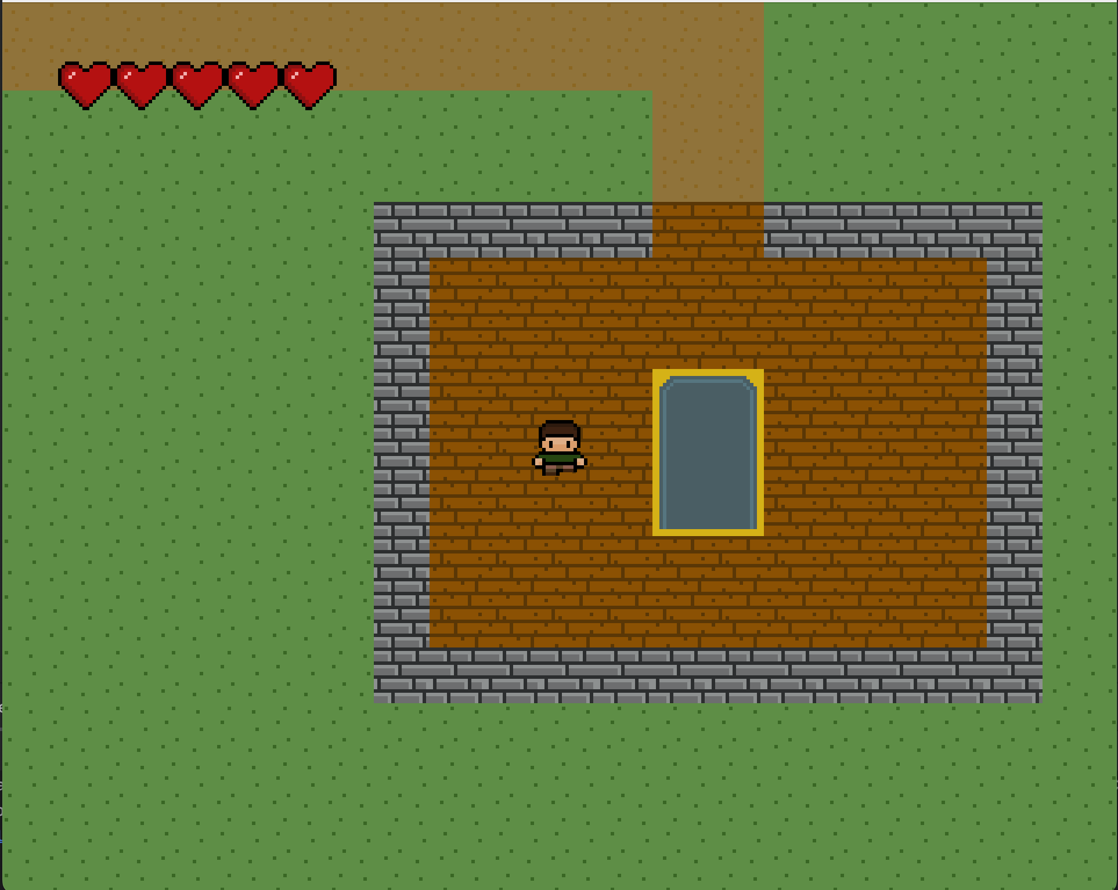

Fig 7. Golden Portal Room

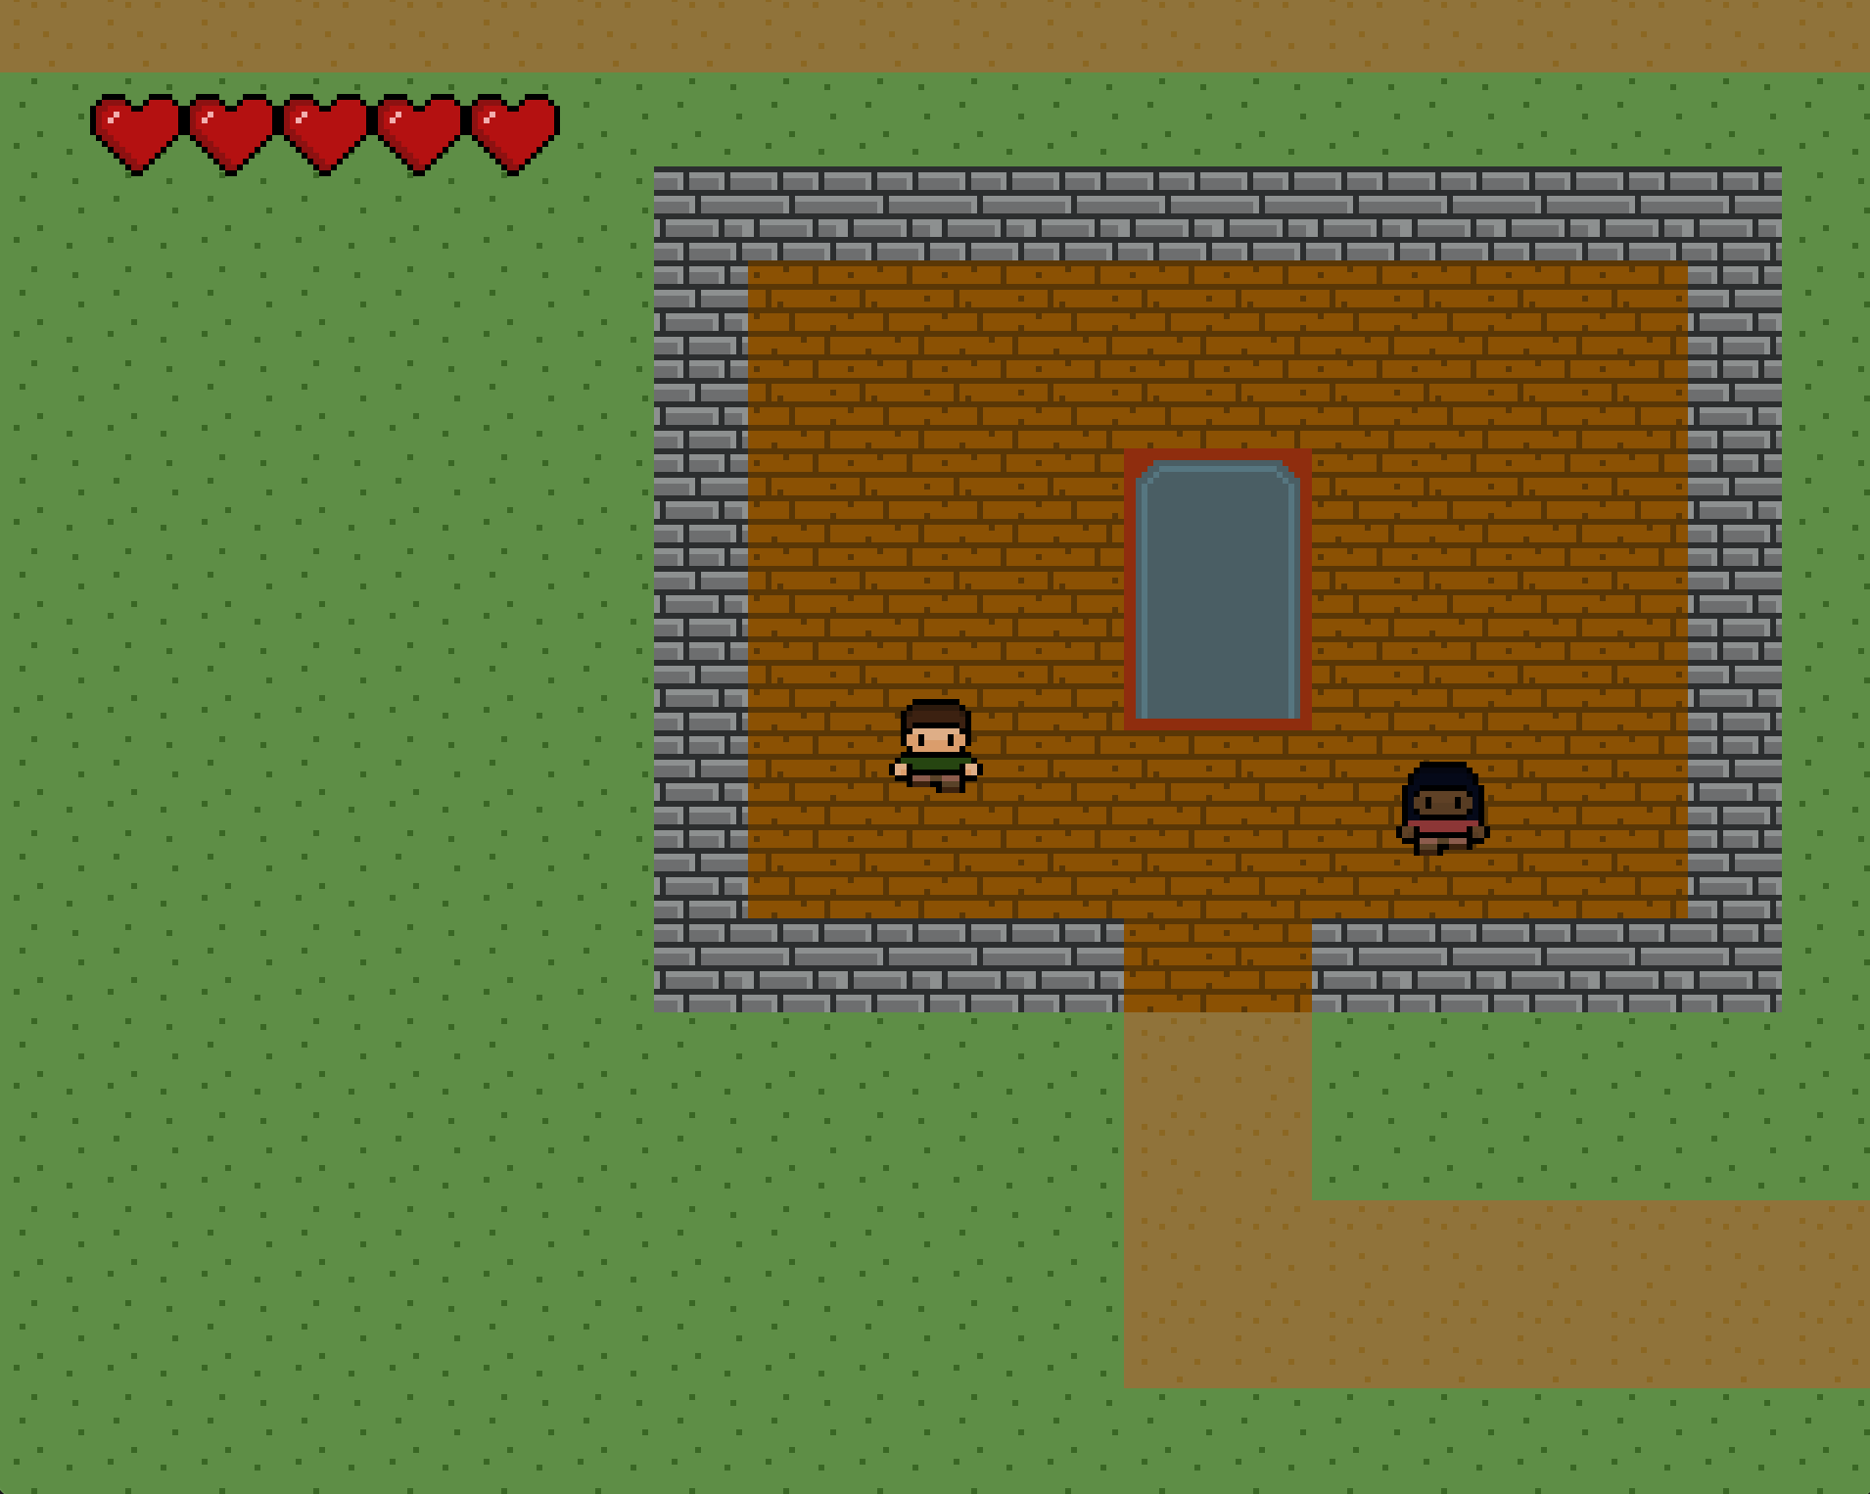

Fig 8. Boss Rush Room

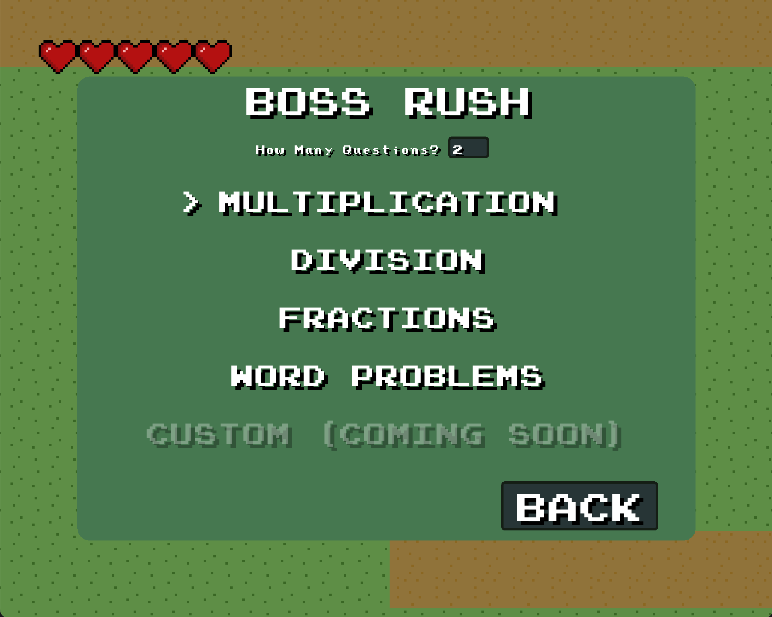

Fig 9. Boss Rush Start Screen

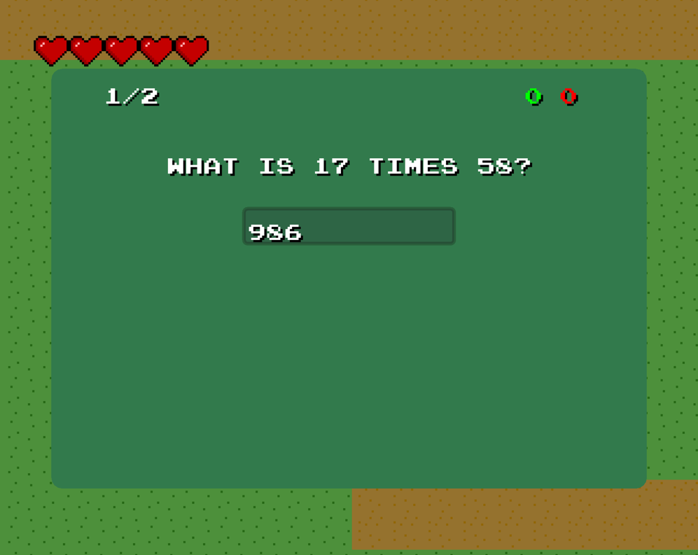

Fig 10. Boss Rush Mode

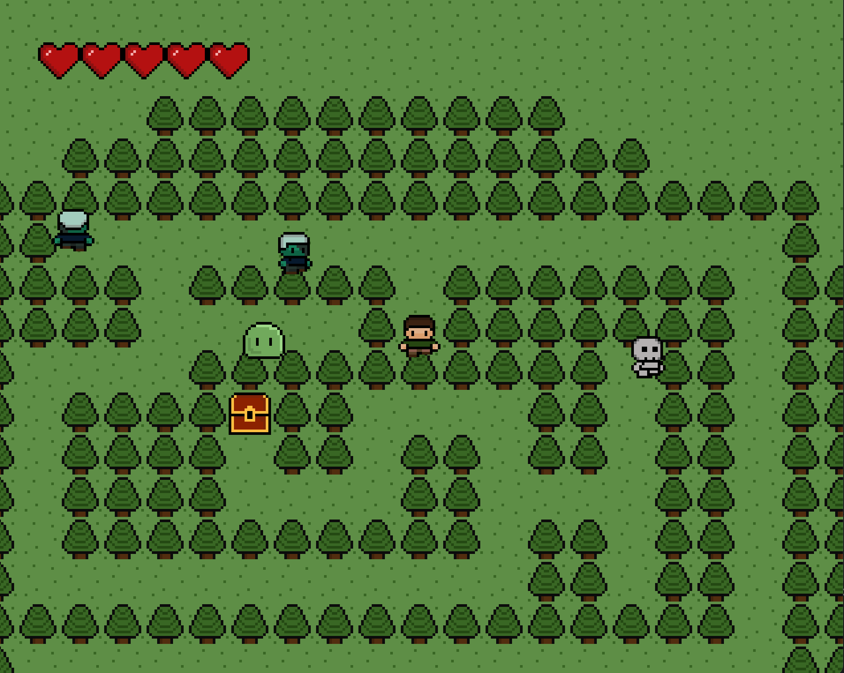

Fig 11. Maze with Super Chest

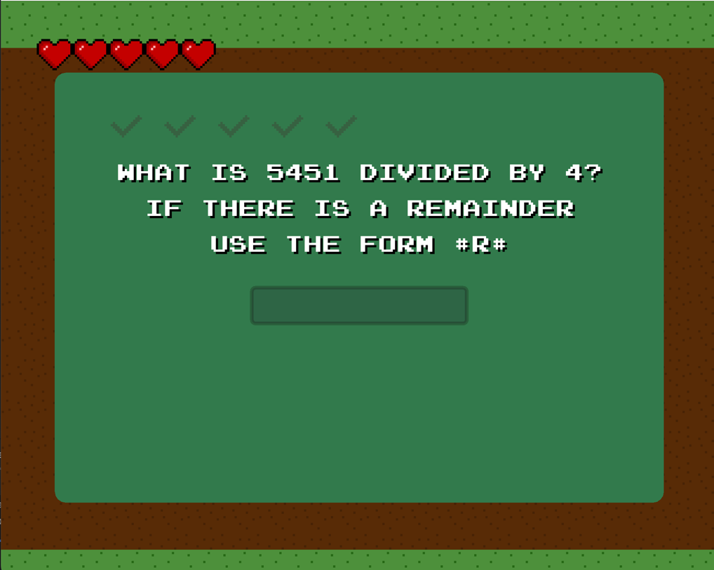

Fig 12. Super Chest Question Screen

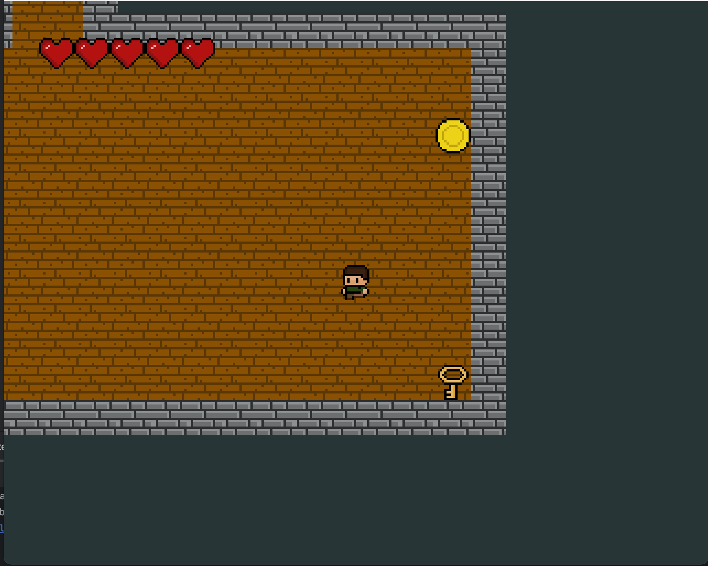

Fig 13. Items located around the dungeon

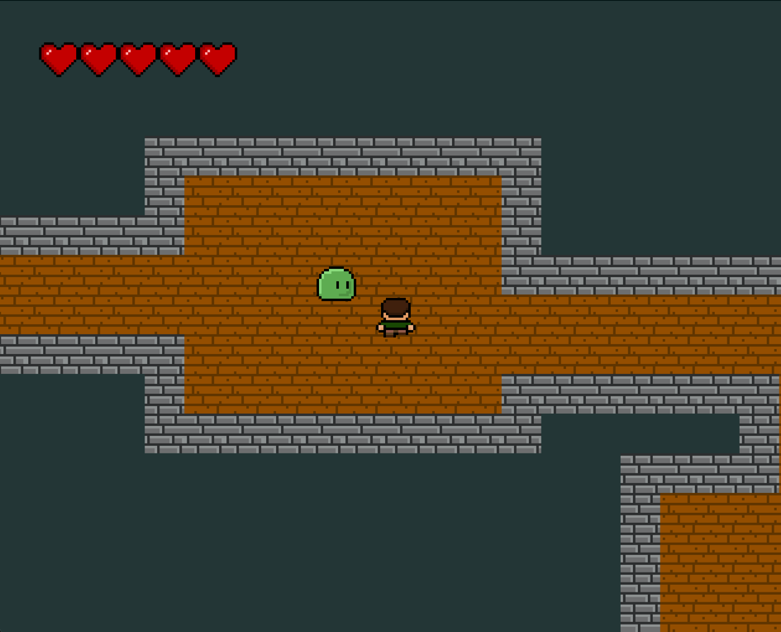

Fig 14. Monsters spawn in the dungeon

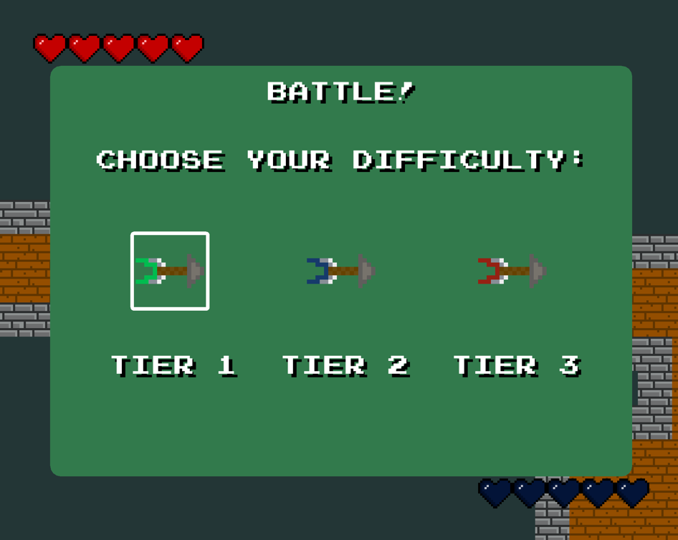

Fig 15. Battle monsters and choose your difficulty

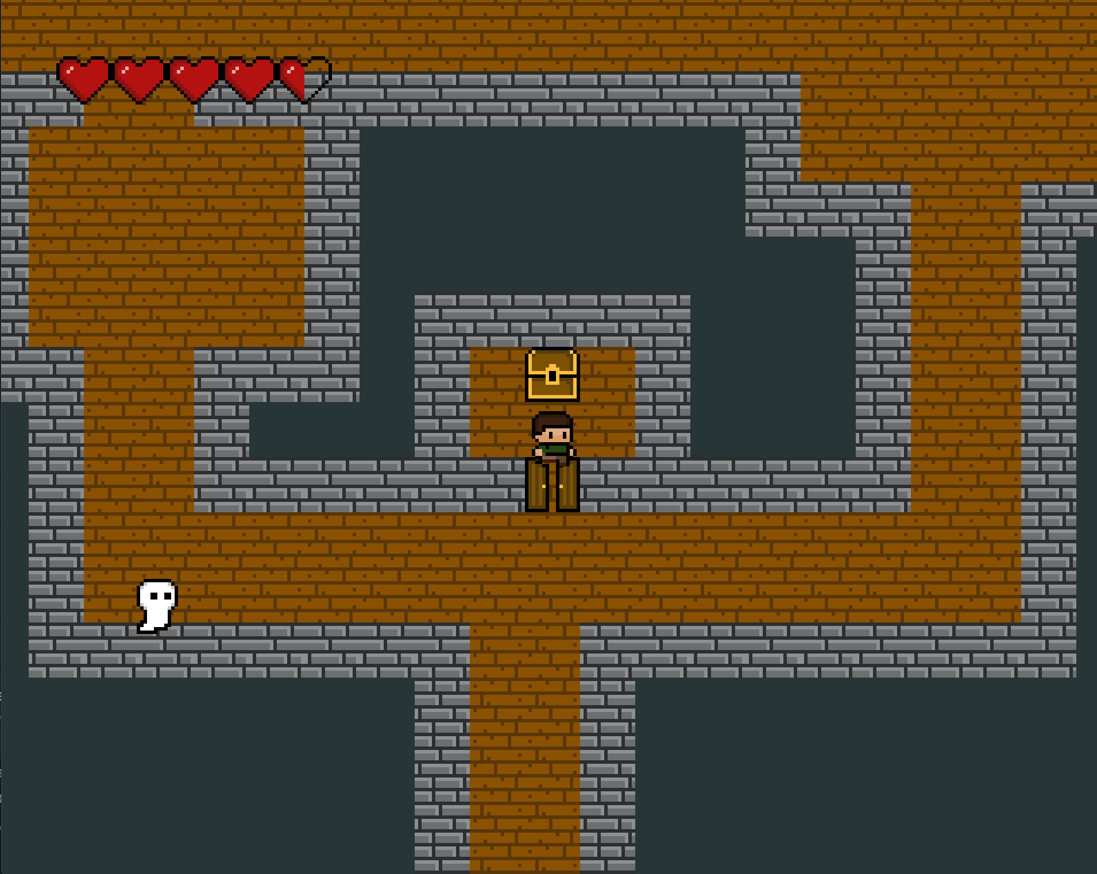

Fig 16. Find chests in the dungeon

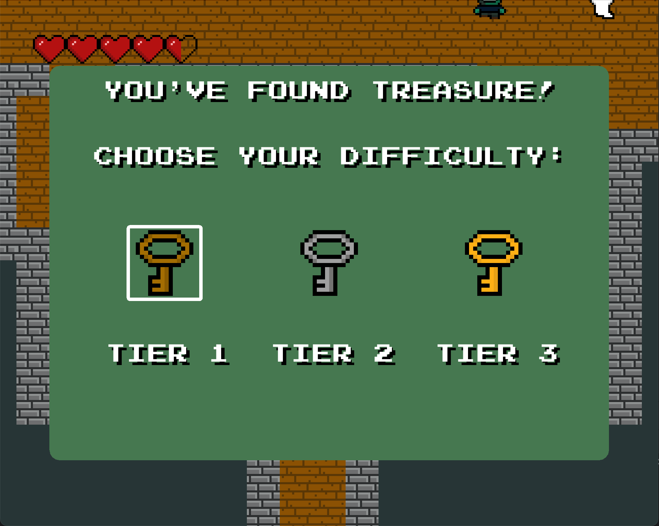

Fig 17. Choose the chest’s difficulty

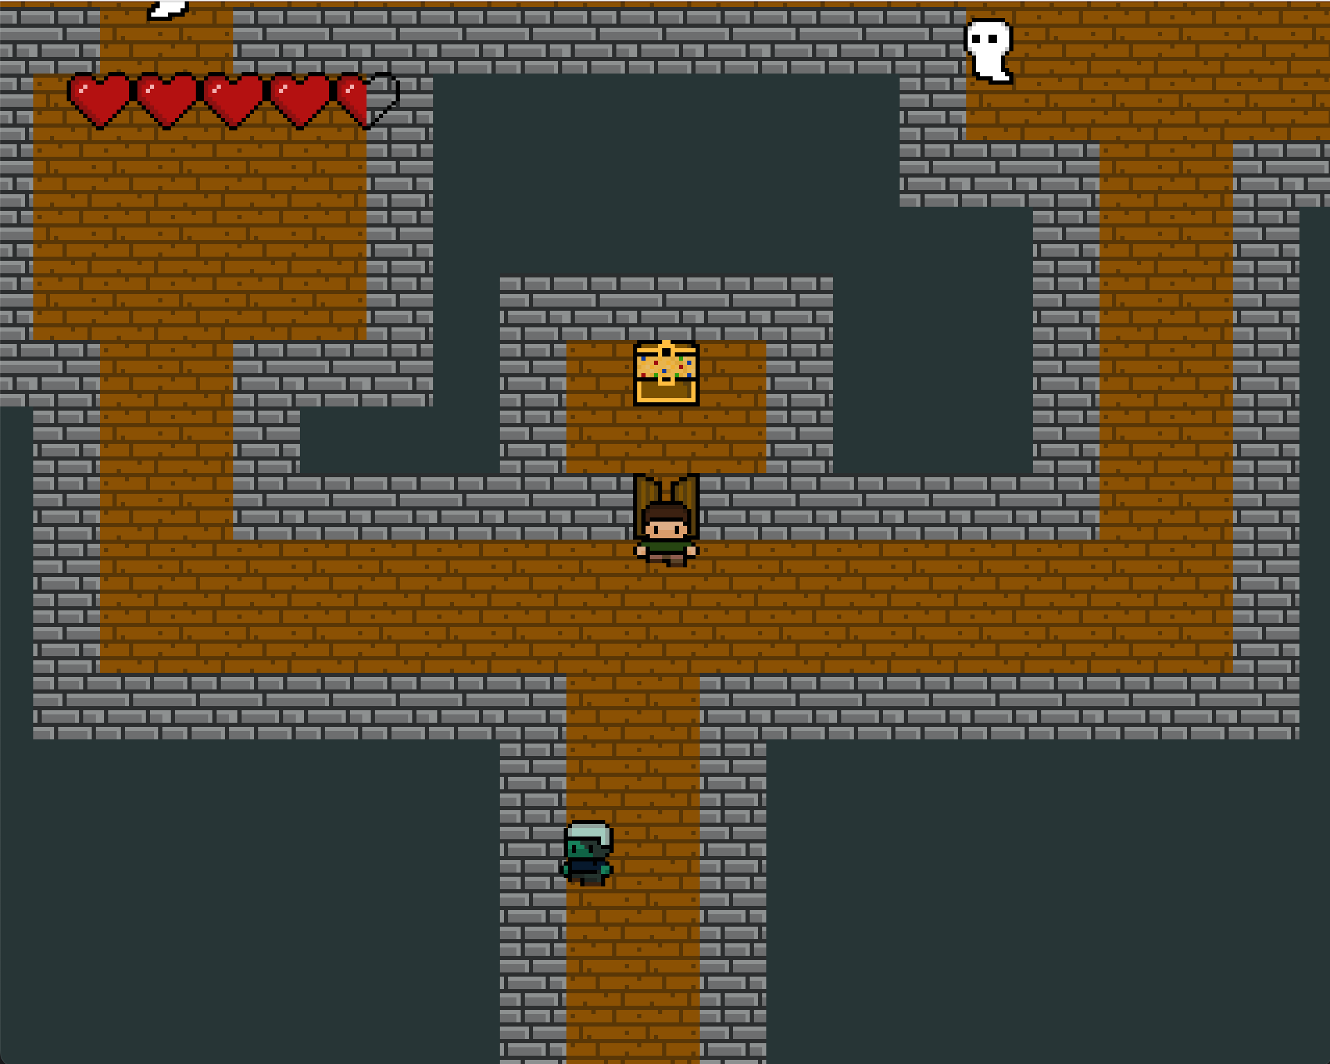

Fig 18. An unlocked chest

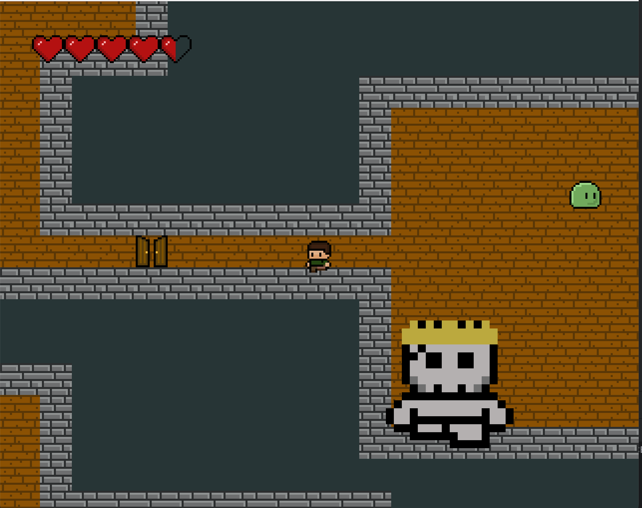

Fig 19. Challenge the Boss

Fig 20. Win the Run

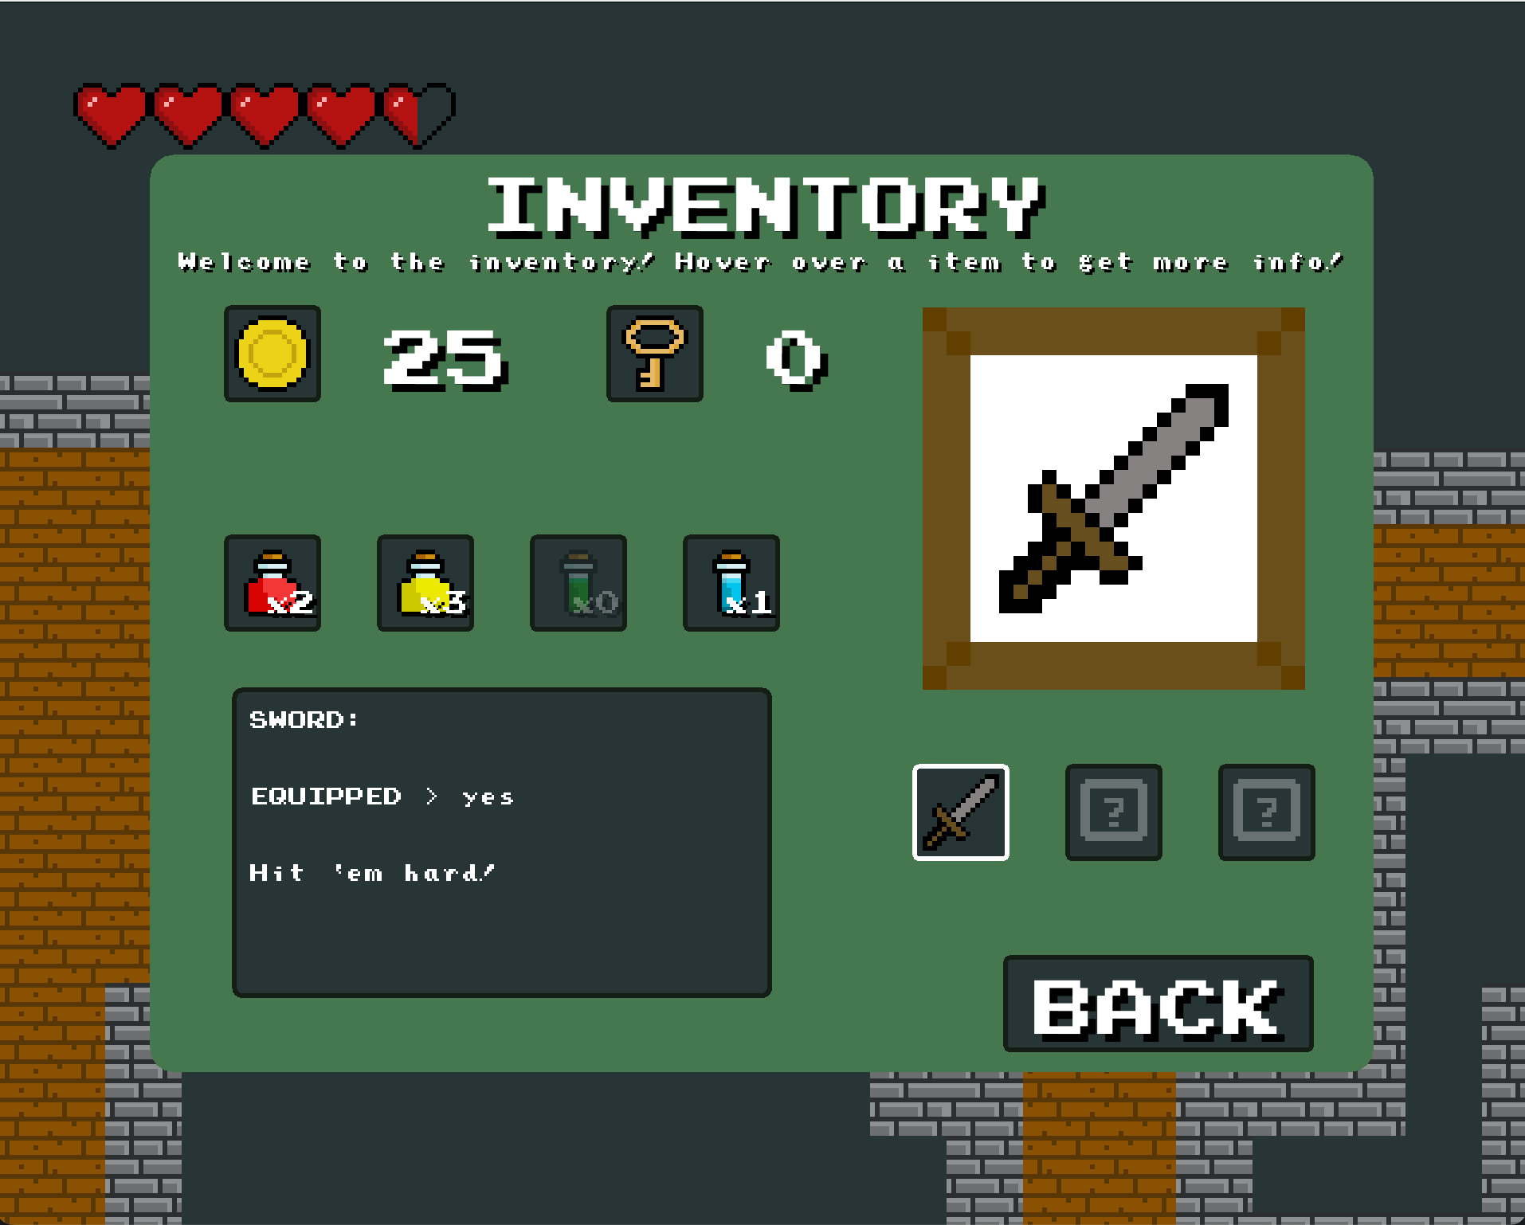

Fig 21. Inventory Screen

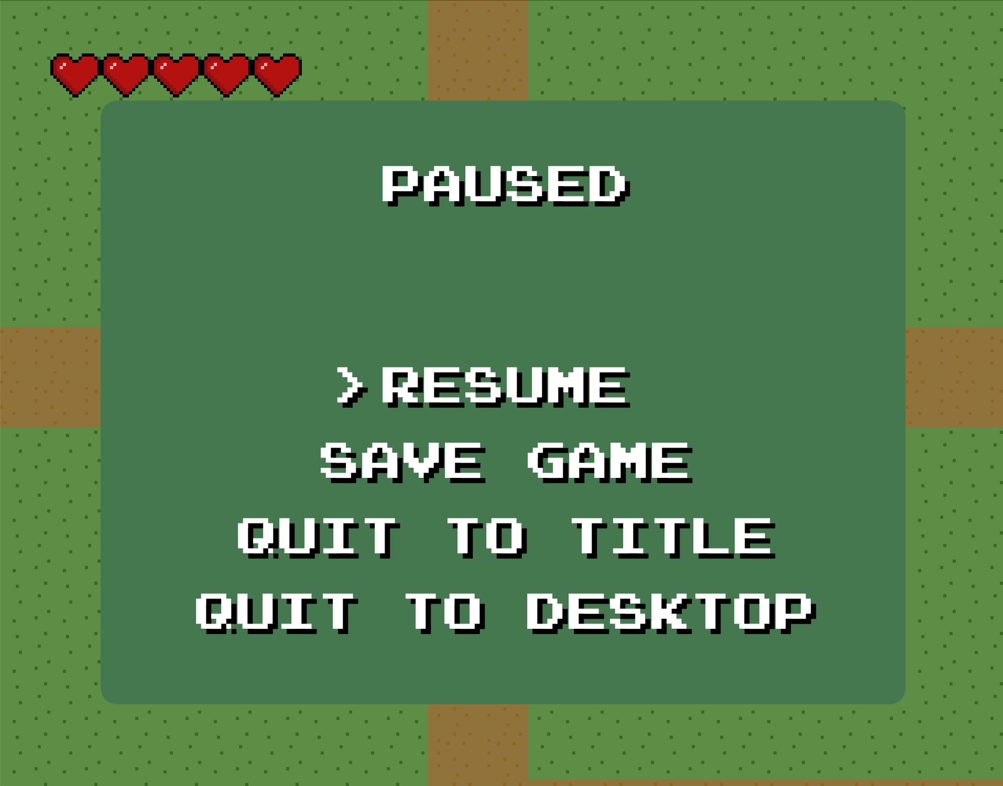

Fig 22. Pause Menu

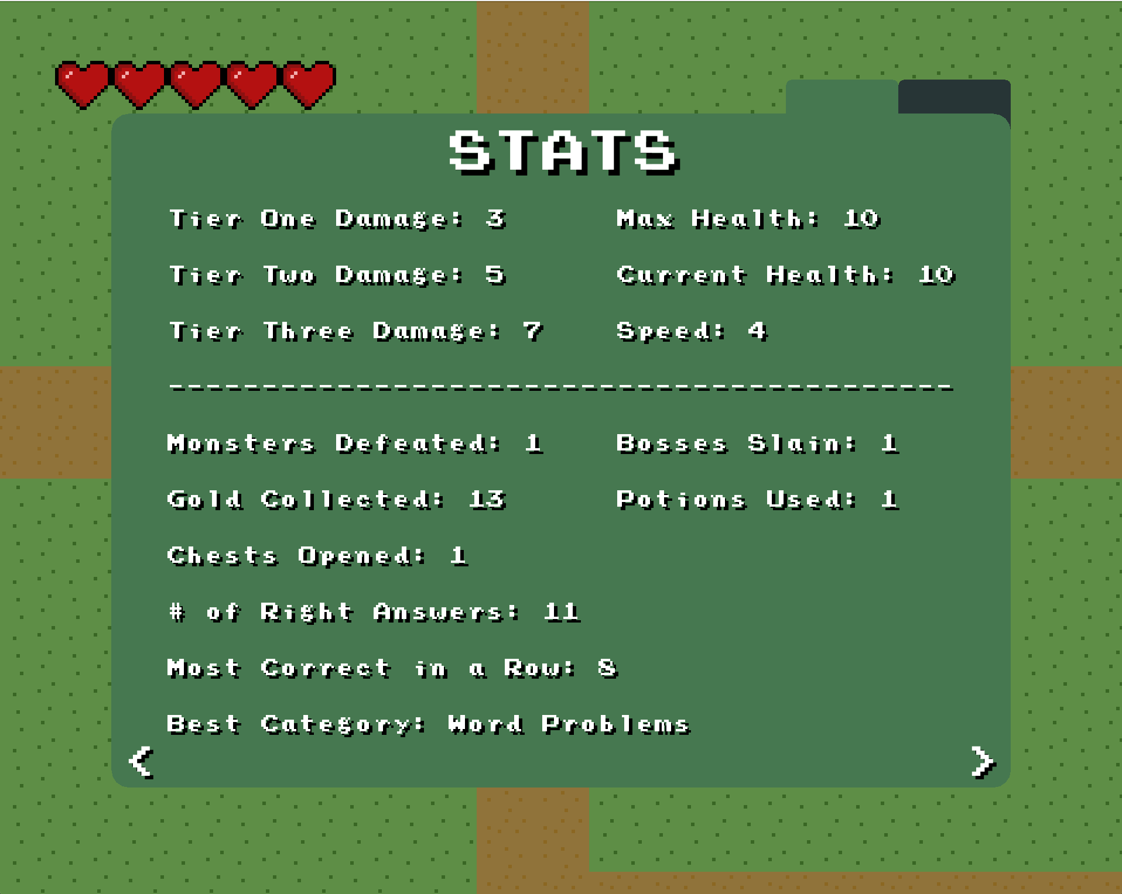

Fig 23. Stats Menu

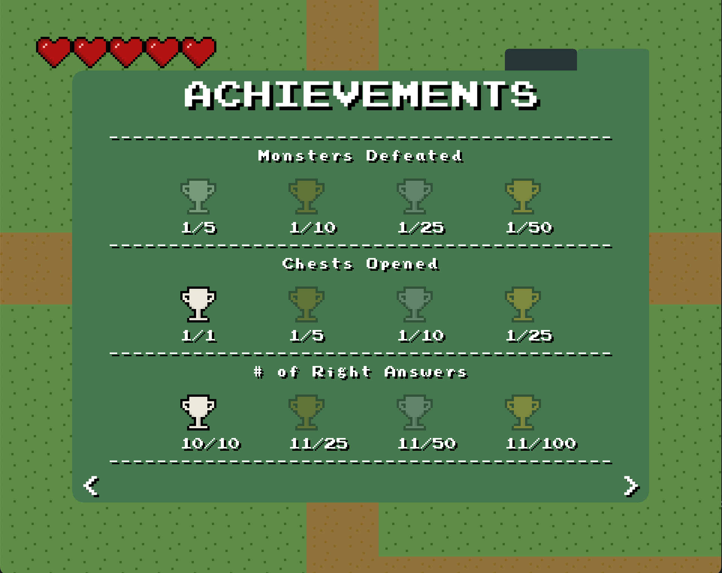

Fig 24. Achievements Menu

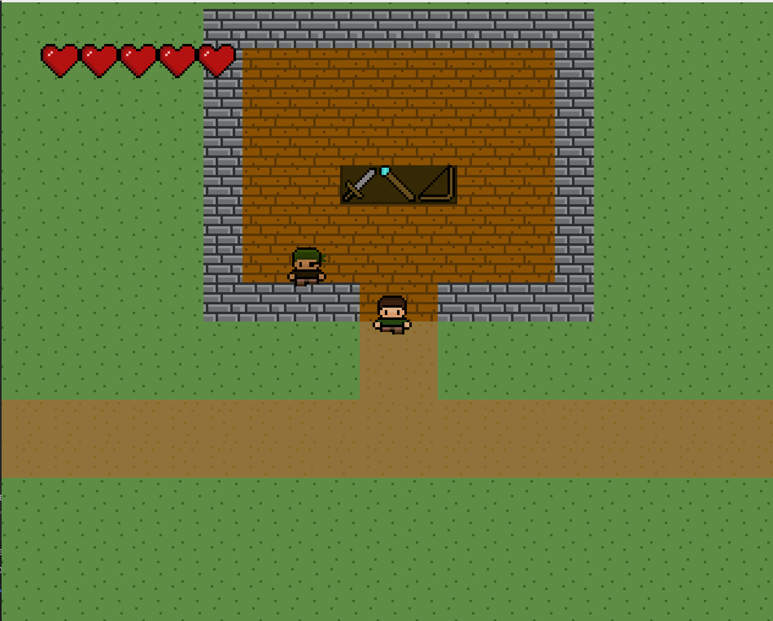

Fig 25. Weapon Master Shop

Fig 26. Purhcase Weapons

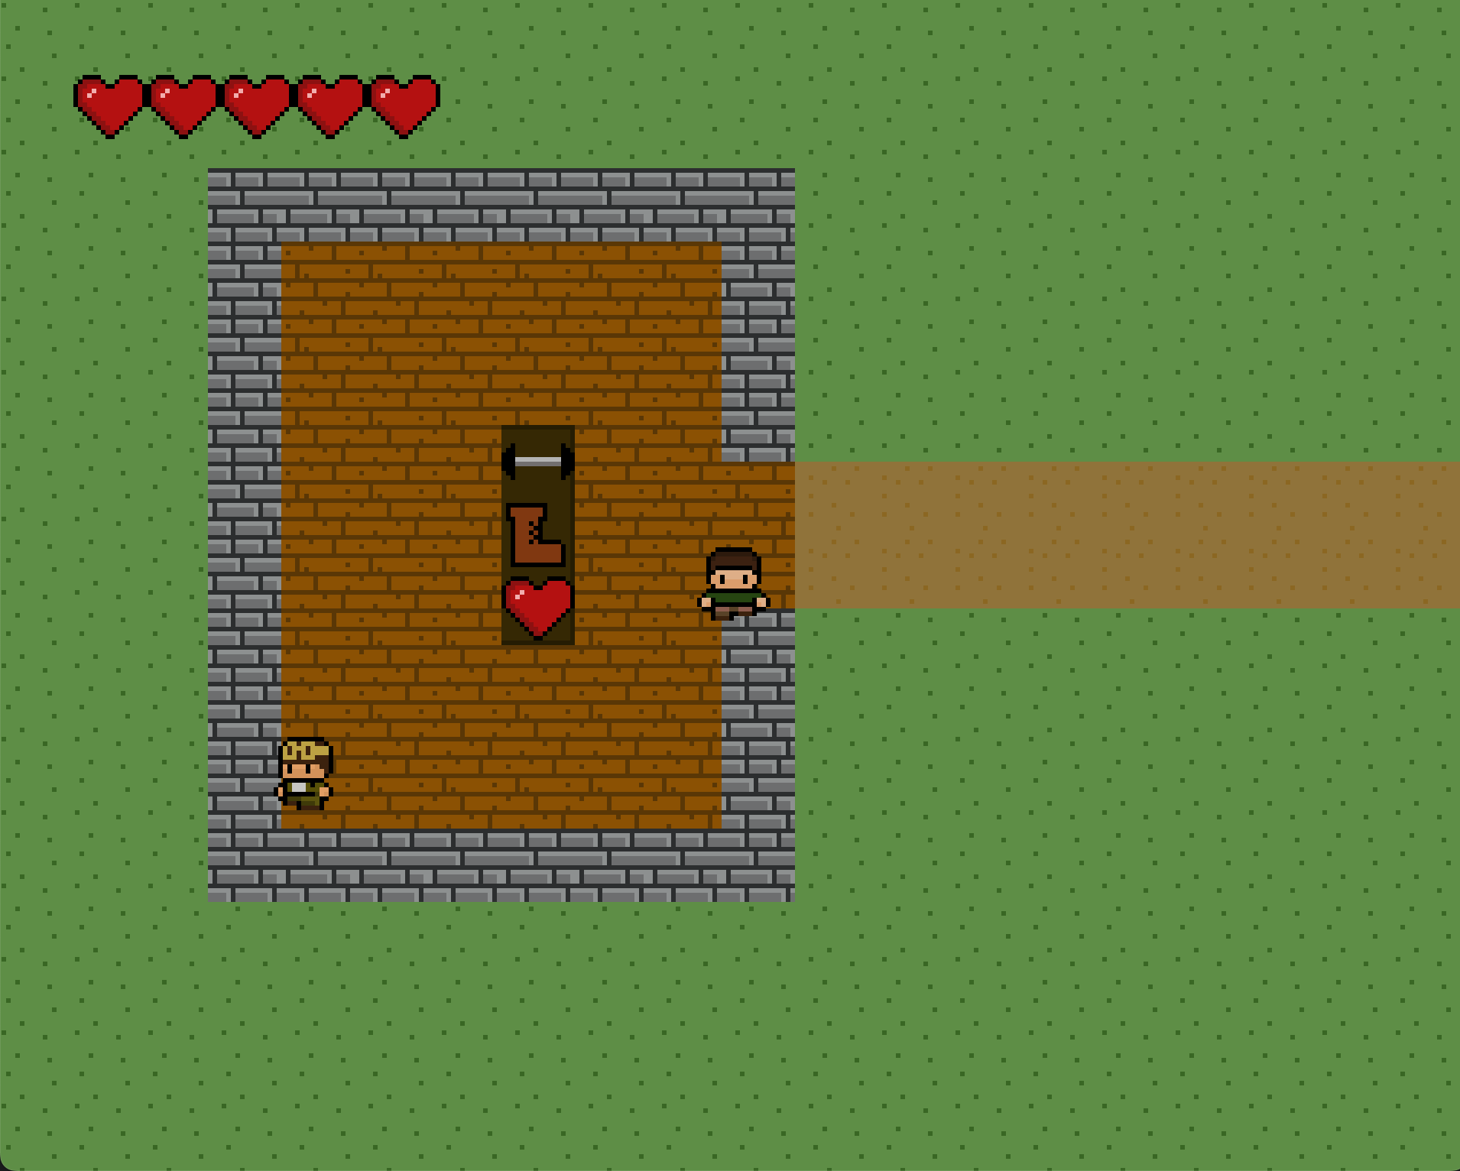

Fig 27. Artificer Shop

Fig 28. Purchase Upgrades

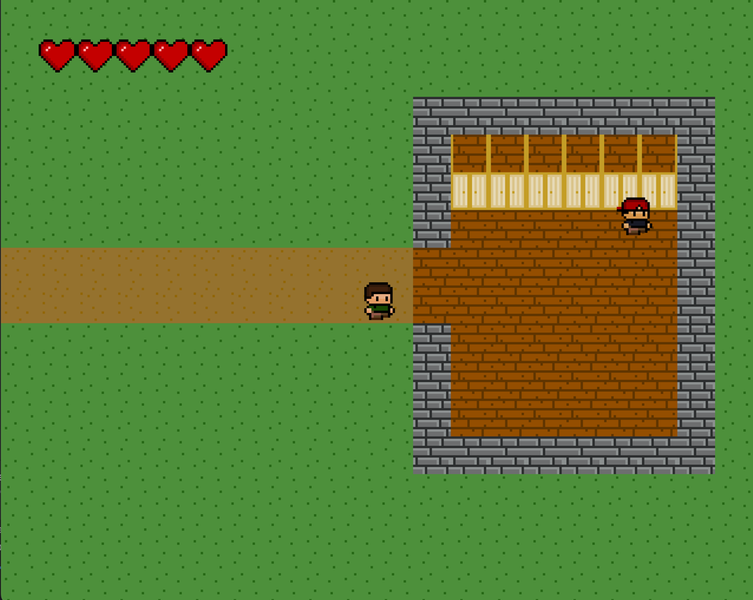

Fig 29. Outfitter Shop

Fig 30. Purchase Outfits

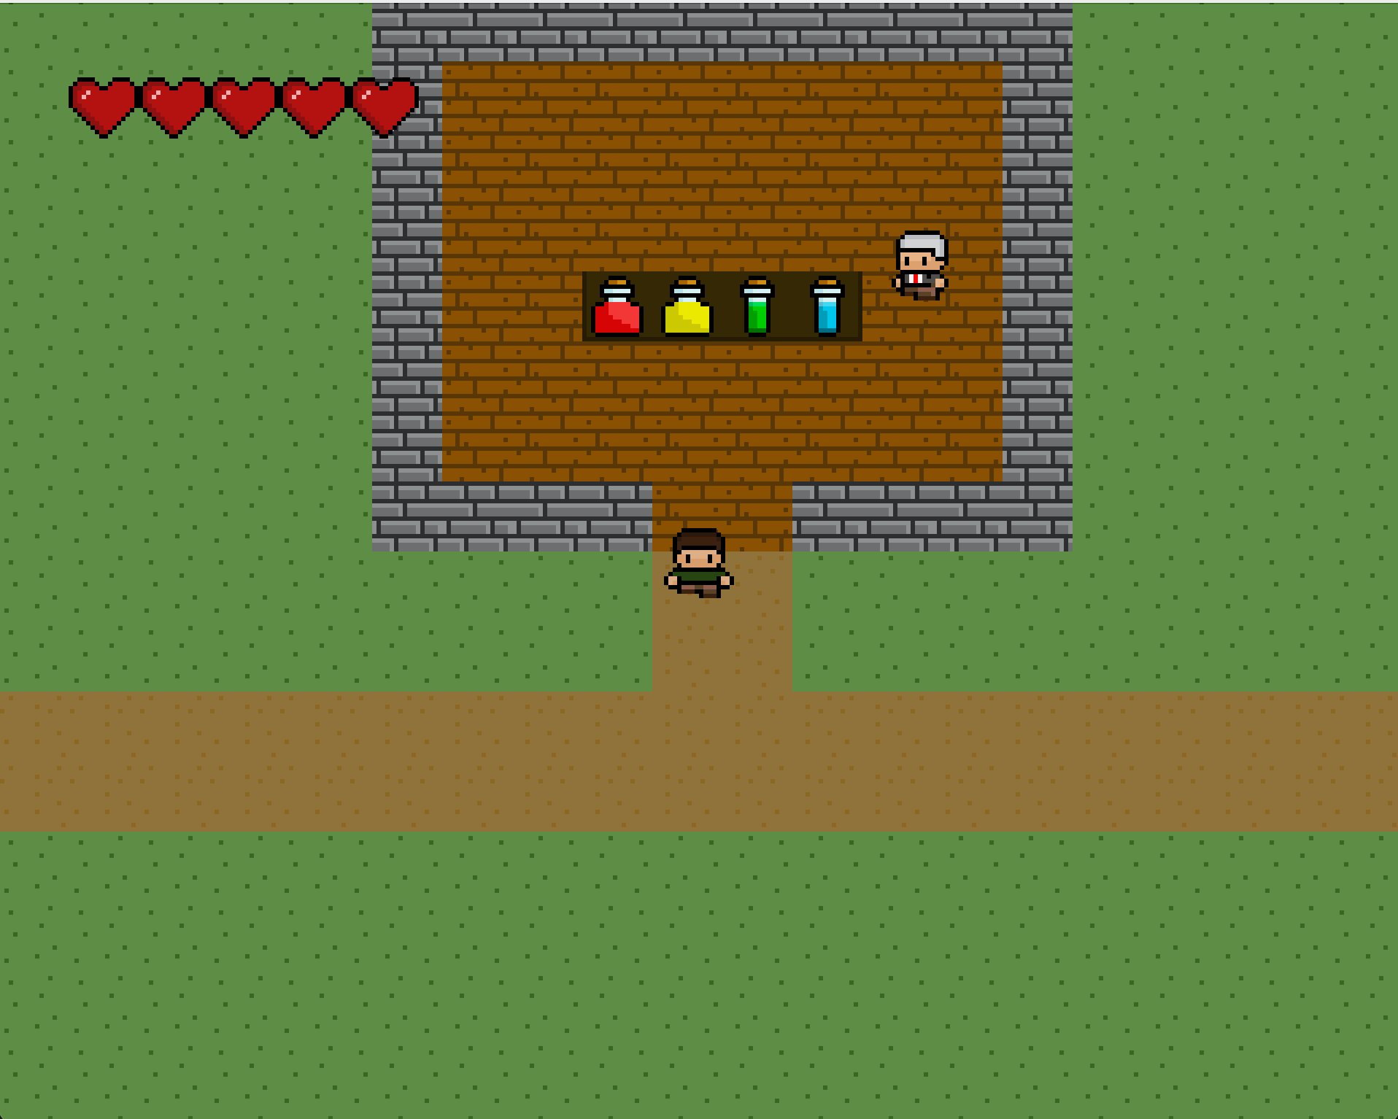

Fig 31. Potion Shop

Fig 32. Purchase Potions

# Test Plan

## Introduction

**1. Overview**

This test plan describes the testing approach for the Realms of Mastery program.

**2. Goals**

The goal of this testing period is to verify that the functionality of Realms of Mastery works according to the specifications and requirements previously created. The test will include playing the game and attempting to cover all possibilities that a player might encounter. This testing period will be used to identify, fix, and retest any bugs or issues found. In addition, a play testing experience conducted with a group of users in the appropriate target range will be completed during this period of testing.

The final product of the testing period will be:

- A ready to play version of Realms of Mastery.

- User-friendly and easy to understand UI and controls.

**3. Constraints**

This testing period will suffer from time-based constraints and scheduling concerns.

## Test Items

**1. Software**

This test will utilize several different software products:

- IntelliJ IDEA Community Edition 2023.2

- Java SE Development Kit 15.0.1 (JDK 15.0.1)

- Java 8

## Features to be Tested

*Note: NPC will refer to Non-Player Character*

- **World Navigation:** It is critical to the project that the player is able to navigate through the world, both in the main area as well as in the dungeon.

**- Menu Navigation:** It is critical to the project the player is able to navigate the various menus that the game implements. These include the start game menu, character selection menu, pause menu, inventory menu, achievements and stats menu, help/tutorial menu, and the shop menus.

- **Saving and Loading:** It is critical to the project that the player is able to save and load their player file. The player will only be able to save in the main area as saving will be disabled within the dungeon. In the main menu, the player will be able to start a new game or load a game.

- **Character Selection:** The player will be able to customize their character selection at the beginning of the game and when visiting the Outfitter NPC. Any items bought from the Outfitter should remain available to the player.

- **Inventory:** The player will be able to navigate their inventory page which will display the player's items. This menu will also allow the player to use potions when appropriate and select from their unlocked weapons. While potions and keys are dungeon specific and will be reset at the end of each run, other items should persist.

- **Potions:** The player will be able to use potions to bolster their journey. These potions include a health potion, speed potion, strength potion, and reroll potion. The speed potion may only be used outside of an encounter while the reroll potion may only be used inside of an encounter. The health and strength potion may be used at any time.

- **Achievements Page:** The player will be able to view their achievements in the game. These achievements include monsters defeated, chests opened, bosses slain, and questions answered correctly.

- **Stats Page:** The player will be able to view their stats in the game. These stats will include both player stats and game stats. Player stats include the player's damage, health, and speed. Game stats include monsters defeated, bosses slain, gold collected, potions used, chests opened, number of right answers, highest streak of correct answers in a row, and the player's best category of questions.

- **NPCs:** The player will be able to interact with several different NPCs. These NPCs include the Outfitter, the Weapon Master, the Artificer, the Doctor, and the Boss Rush Manager. Each of these NPCs will have menu for the player to navigate that will allow them to purchase items or complete other functions.

- **Shopping Feature:** The NPCs will have shops that will allow the player to purchase things such as new outfits, potions, and weapons. Any unlockable items will be permanently unlocked on purchase.

- **Fighting Monsters:** In the dungeon, players will encounter a variety of monsters. These monsters include zombies, skeletons, ghosts, and slimes. When the player fights a monster they will be able to choose the difficulty of their questions. Higher difficulty questions will deal more damage to the monster if the player gets the answer correct. However, if they are incorrect, they will lose more health on a higher difficulty question. Upon defeating a monster the player will be rewarded with a small amount of gold and the chance to get a potion.

- **Treasure Collection:** In the dungeon, players will encounter chests that contain gold. Depending on the difficulty of the question the player will receive more or less gold. The player will have 3 attempts to unlock the chest, after the third failed attempt the chest will be locked for the rest of the run.

- **Randomized Questions:** When a player interacts with a chest or a monster they will be presented with a question from a random category the corresponds to their chosen difficulty. The categories currently implemented are Multiplication, Division, Fractions, and Word Problems.

- **Boss Rush mode:** A Boss Rush mode will allow the player to choose a category and difficulty tier in order to practice their skills against an onslaught of monsters.

## Features Not to be Tested

The below features are requirements that might not be implemented in the original version of this project, but will eventually be added. If these are implemented prior to the start of testing, they will also be within the scope of the features to be tested.

- **Auto-save:** Support for auto-saving the game.

- **Fighting Style Selection:** The player will be able to select between an ELA or Math-based fighting style.

- **ELA Questions:** Support for ELA questions to appear in the game.

- **Personalized Boss Rush:** While the questions found in the main game will remain fixed, there is the potential for the boss rush feature to be personalized with custom questions provided by teachers.

## Approach

**Testing Methods**

Testing will consist of a case-by-case basis as well as testing the overall functionality of the game. Each feature will be tested individually to ensure its functionality. When a bug is found in a feature, testing will temporarily pause in order to fix the bug. Once the bug has been fixed, testing for that feature will restart to ensure that the bug fix did not cause any other unintended issues. Once each feature has been properly tested, the entire game will be play tested by the developer and others to ensure the overall cohesiveness and functionality of the game.

Testing will be done manually and will test both expected and unexpected input to see how the program handles it.

**Testing Levels**

- Component testing will be used to ensure that each feature of the software functions according to its specifications and requirements.

- Integration testing will be used to ensure that certain components work together. For example, items purchased from NPCs should persist when the game is saved and reloaded.

- System testing will be performed to ensure that all components are working together.

## Item Pass/Fail Criteria

- **World Navigation:**

- Pass: The player will be able to use the 'W', 'A', 'S', and 'D' keys to move throughout the world and the dungeons.

- Fail: The 'W', 'A', 'S', and 'D' keys will not move the player in the appropriate way.

- **Menu Navigation:**

- Pass: The player will be able to use the 'W', 'A', 'S', and 'D' to move throughout the menu and 'Enter' to select buttons. The player will be able to access menus with specific keys.

- Pause Menu - 'P'

- Inventory Menu - 'I'

- Achievement/Stats Menu - 'O'

- Map – ‘M’

- Help Menu – ‘H’

- Fail: Certain parts of the menu will not be accessed correctly, or the keys do not behave as expected.

- **Saving and Loading:**

- Pass: The player will be able to save and load their game without loss of data.

- Fail: The player will not be able to successfully save or load, or there is a loss of data.

- **Character Selection:**

- Pass: The player will be able to use the 'W', 'A', 'S', 'D', and 'Enter' keys to select different gender, hair color, skin color, and shirt color to customize their character. When a player selects a new customization the player image will update to reflect these changes.

- Fail: The player will not be able to select available options or the player image will not be updated.

**- Inventory:**

- Pass: The player will be able to navigate the inventory screen using the 'W', 'A', 'S', 'D', and 'Enter' keys. They will be able to see an accurate representation of their current supplies including number of coins, keys, potions, and availability of weapons. The player will also be able to use potions and select a new weapon. Certain potions can only be used in an encounter or outside of one, the player should not be allowed to use a encounter-specific potion outside of an encounter or vice versa.

- Fail: The player will not be able to navigate the inventory screen or select available weapons and potions. Information being represented incorrectly after manipulation to resources will also constitute failure. Finally, if the player is able to use a potion when it is not intended that will also constitute failure.

**- Potions:**

- Pass: Several conditions must be met to pass:

- Reroll Potion:

- Can only be used during an encounter

- Will create a new question for the player of the same difficulty

- Health Potion:

- Can be used at any time

- Will increase the player's health by a number but will not push it above the max health

- Strength Potion:

- Can be used at any time

- Will increase the player's damage by a number for three fights

- After three fights the player's damage will return to normal

- Speed Potion:

- Can only be used outside of an encounter

- Will increase the player's speed for two minutes

- At the end of the two minutes the player's speed will return to normal

- Fail: Several conditions could cause this to fail:

- Reroll Potion:

- Used outside of an encounter

- Creates a question of a different difficulty or fails to generate a new question

- Health Potion:

- Does not increase the player's health or increases it above the max health

- Strength Potion:

- Player's damage is not increased

- After three fights the player's damage is not returned to normal

- Speed Potion:

- Used inside of an encounter

- Does not increase player's speed

- At the end of the two minutes the player's speed is not returned to normal

**- Achievements Page:**

- Pass: The player is able to view their achievements and see an accurate representation of the achievements they have earned and their progress towards others.

- Fail: The player is not able to access the achievements page or their achievements are not accurately represented.

**- Stats Page:**

- Pass: The player is able to view their stats and see an accurate representation of their player stats and game stats. These stats should also update as they are manipulated. For example, a player's stats should reflect an increase in damage after using a strength potion and should reflect a return to normal damage once the potion's effect are gone.

- Fail: The player is no able to access the stats page or their stats are not accurately recorded.

- **NPCs:**

- Pass: The player will be able to interact with all NPCs and NPCs will appear in their correct locations.

- Fail: The player will not be able to interact with one or more NPCs or NPCs appear in inappropriate locations.

**- Shopping Feature:**

- Pass: The player will be able to purchase items from the NPCs in their shops. These unlockable items should remain available after purchase and the player should not be able to purchase items that they do not have the gold for.

- Fail: The player is unable to purchase an item that they have the gold for or they are able to purchase an item they cannot afford. Another failure condition is if items purchased do not remain available.

**- Fighting Monsters:**

- Pass: The player will engage in a monster fight upon interacting with a monster or upon the monster running into them. The player will fight the monster in a sequence of selecting a difficulty and answering a question until either the monster or the player has been defeated. If the player answers incorrectly, the correct answer will be given to them.

- Fail: A player and monster running into each other does not trigger a fight. Other failure conditions include if the sequence of the fight is not followed or the incorrect answer is shown.

**- Treasure Collection:**

- Pass: The player will attempt to unlock a chest upon running into it. The player will be given three chances to unlock it, after the third wrong answer the chest will be locked for the remainder of the run. The chest will give the player an amount of gold depending on the difficulty level that was chosen.

- Fail: The player is not able to start an unlock attempt or is locked out of the chest before the third wrong answer. Additionally, if the player receives an inappropriate amount of gold for their chosen difficulty level it will be considered a failure.

**- Randomized Questions:**

- Pass: Each category (Multiplication, Division, Fractions, Word Problems) will be represented at random within a run, however, no run should consist of only one type of question.

- Fail: One category is never represented or only one or two categories are represented.

**- Boss Rush mode:**

- Pass: The player will be able to start the boss rush mode and will able to choose a category and difficulty to practice.

- Fail: The player is unable to start the boss rush mode or is not able to limit questions to a category and difficulty.

## Test Cases

|  |  |  |  |
| --- | --- | --- | --- |
| **Tested Feature** | **Action** | **Expected Result** | **Result** |
| World Navigation | Press ‘W’ to move the character up | The character will move up | Pass |

|  |  |  |  |
| --- | --- | --- | --- |
| **Tested Feature** | **Action** | **Expected Result** | **Result** |
| World Navigation | Press ‘A’ to move the character left | The character will move left | Pass |

|  |  |  |  |
| --- | --- | --- | --- |
| **Tested Feature** | **Action** | **Expected Result** | **Result** |
| World Navigation | Press ‘S’ to move the character down | The character will move down | Pass |

|  |  |  |  |
| --- | --- | --- | --- |
| **Tested Feature** | **Action** | **Expected Result** | **Result** |
| World Navigation | Press ‘D’ to move the character right | The character will move right | Pass |

|  |  |  |  |
| --- | --- | --- | --- |
| **Tested Feature** | **Action** | **Expected Result** | **Result** |
| Menu Navigation | Press ‘P’ to access the Pause menu | The Pause menu will open | Pass |

|  |  |  |  |
| --- | --- | --- | --- |
| **Tested Feature** | **Action** | **Expected Result** | **Result** |
| Menu Navigation | Press ‘I’ to access the Inventory | The Inventory will open | Pass |

|  |  |  |  |
| --- | --- | --- | --- |
| **Tested Feature** | **Action** | **Expected Result** | **Result** |
| Menu Navigation | Press ‘O’ to access the Stats and Achievements Page | The Stats and Achievements Page will open | Pass |

|  |  |  |  |
| --- | --- | --- | --- |
| **Tested Feature** | **Action** | **Expected Result** | **Result** |
| Menu Navigation | Press ‘H’ to access the Help menu | The Help menu will open | Pass |

|  |  |  |  |
| --- | --- | --- | --- |
| **Tested Feature** | **Action** | **Expected Result** | **Result** |
| Menu Navigation | Press ‘M’ to access the Map | The Map will open | Pass |

|  |  |  |  |
| --- | --- | --- | --- |
| **Tested Feature** | **Action** | **Expected Result** | **Result** |
| Menu Navigation | Use ‘W’, ‘A’, ‘S’, ‘D’, and enter to navigate each menu | No interactable object in a menu should be unreachable and each menu item should trigger the appropriate action | Pass |

|  |  |  |  |
| --- | --- | --- | --- |
| **Tested Feature** | **Action** | **Expected Result** | **Result** |
| Saving and Loading | Save the game after completing a run, and reload the game | The achievements, stats, and inventory of the player will reflect that one run has been completed | Pass |

|  |  |  |  |
| --- | --- | --- | --- |
| **Tested Feature** | **Action** | **Expected Result** | **Result** |
| Saving and Loading | Attempt to save the game in the middle of a run | The game will not allow the player to save in the middle of a run | Pass |

|  |  |  |  |
| --- | --- | --- | --- |
| **Tested Feature** | **Action** | **Expected Result** | **Result** |
| Character Selection | Select a girl character, with red hair, light skin, and a white shirt | The player’s character will change to reflect these selections | Pass |

|  |  |  |  |
| --- | --- | --- | --- |
| **Tested Feature** | **Action** | **Expected Result** | **Result** |
| Character Selection | Select a boy character, with black hair, dark skin, and a red shirt | The player’s character will change to reflect these selections | Pass |

|  |  |  |  |
| --- | --- | --- | --- |
| **Tested Feature** | **Action** | **Expected Result** | **Result** |
| Inventory | Buy a sword for 50 gold | The player will lose 50 gold and will now have the sword available | Pass |

|  |  |  |  |
| --- | --- | --- | --- |
| **Tested Feature** | **Action** | **Expected Result** | **Result** |
| Inventory | Equip the sword | The sword should appear as being equipped in the inventory and in battles | Pass |

|  |  |  |  |
| --- | --- | --- | --- |
| **Tested Feature** | **Action** | **Expected Result** | **Result** |
| Potions | Use a health potion | The player should gain 2 health, but should not go above max health | Pass |

|  |  |  |  |
| --- | --- | --- | --- |
| **Tested Feature** | **Action** | **Expected Result** | **Result** |
| Potions | Use a strength potion | The player’s damage should increase for three fights and then return to normal | Pass |

|  |  |  |  |
| --- | --- | --- | --- |
| **Tested Feature** | **Action** | **Expected Result** | **Result** |
| Potions | Use a speed potion outside of combat | The player’s speed should be increased for 2 minutes and then return to normal | Pass |

|  |  |  |  |
| --- | --- | --- | --- |
| **Tested Feature** | **Action** | **Expected Result** | **Result** |
| Potions | Attempt to use a speed potion while in combat | This action should be prohibited | Pass |

|  |  |  |  |
| --- | --- | --- | --- |
| **Tested Feature** | **Action** | **Expected Result** | **Result** |
| Potions | Use a reroll potion while in combat | The question should be rerolled to one of the same difficulty | Pass |

|  |  |  |  |
| --- | --- | --- | --- |
| **Tested Feature** | **Action** | **Expected Result** | **Result** |
| Potions | Attempt to use a reroll potion outside of combat | This action should be prohibited | Pass |

|  |  |  |  |
| --- | --- | --- | --- |
| **Tested Feature** | **Action** | **Expected Result** | **Result** |
| Achievements Pages | Open a chest | The first trophy (white) for opening chests should be unlocked | Pass |

|  |  |  |  |
| --- | --- | --- | --- |
| **Tested Feature** | **Action** | **Expected Result** | **Result** |
| Achievements Pages | Defeat a monster | Each trophy for defeating a monster should show 1/ ? | Pass |

|  |  |  |  |
| --- | --- | --- | --- |
| **Tested Feature** | **Action** | **Expected Result** | **Result** |
| Stats Pages | Use a strength potion | The player’s damage stats should be increased | Pass |

|  |  |  |  |
| --- | --- | --- | --- |
| **Tested Feature** | **Action** | **Expected Result** | **Result** |
| Stats Pages | Buy a health upgrade | The player’s max health should be increased | Pass |

|  |  |  |  |
| --- | --- | --- | --- |
| **Tested Feature** | **Action** | **Expected Result** | **Result** |
| NPCs | Interact with the Outfitter | The Outfitter’s shop should open | Pass |

|  |  |  |  |
| --- | --- | --- | --- |
| **Tested Feature** | **Action** | **Expected Result** | **Result** |
| NPCs | Interact with the Weapon Master | The Weapon Master’s shop should open | Pass |

|  |  |  |  |
| --- | --- | --- | --- |
| **Tested Feature** | **Action** | **Expected Result** | **Result** |
| Shopping Feature | Buy the hat from the Outfitter and equip it | The player’s character should have a hat | Pass |

|  |  |  |  |
| --- | --- | --- | --- |
| **Tested Feature** | **Action** | **Expected Result** | **Result** |
| Shopping Feature | Attempt to but something you do not have enough gold for | This action should be prohibited | Pass |

|  |  |  |  |
| --- | --- | --- | --- |
| **Tested Feature** | **Action** | **Expected Result** | **Result** |
| Shopping Feature | Attempt to buy something you already own | This action should be prohibited | Pass |

|  |  |  |  |
| --- | --- | --- | --- |
| **Tested Feature** | **Action** | **Expected Result** | **Result** |
| Fighting Monsters | Run into a monster | A fight should be triggered | Pass |

|  |  |  |  |
| --- | --- | --- | --- |
| **Tested Feature** | **Action** | **Expected Result** | **Result** |
| Fighting Monsters | Answer a question correctly | The monster’s health should decrease | Pass |

|  |  |  |  |
| --- | --- | --- | --- |
| **Tested Feature** | **Action** | **Expected Result** | **Result** |
| Fighting Monsters | Answer a question incorrectly | The player’s health should decrease and the correct answer should be shown | Pass |

|  |  |  |  |
| --- | --- | --- | --- |
| **Tested Feature** | **Action** | **Expected Result** | **Result** |
| Treasure Collection | Answer a question correctly on a regular chest | The chest should open and an appropriate reward should be given based on difficulty | Pass |

|  |  |  |  |
| --- | --- | --- | --- |
| **Tested Feature** | **Action** | **Expected Result** | **Result** |
| Treasure Collection | Answer a question incorrectly on a regular chest | One X should be filled in | Pass |

|  |  |  |  |
| --- | --- | --- | --- |
| **Tested Feature** | **Action** | **Expected Result** | **Result** |
| Treasure Collection | Answer 3 questions incorrectly on a regular chest | The chest should be locked | Pass |

|  |  |  |  |
| --- | --- | --- | --- |
| **Tested Feature** | **Action** | **Expected Result** | **Result** |
| Treasure Collection | Answer a question correctly on a super chest | One check mark should be filled in | Pass |

|  |  |  |  |
| --- | --- | --- | --- |
| **Tested Feature** | **Action** | **Expected Result** | **Result** |
| Treasure Collection | Answer a question incorrectly on a super chest | The treasure collection screen should close and progress should be reset | Pass |

|  |  |  |  |
| --- | --- | --- | --- |
| **Tested Feature** | **Action** | **Expected Result** | **Result** |
| Treasure Collection | Answer 5 questions correctly on a super chest | The chest should be open and the player should be rewarded | Pass |

|  |  |  |  |
| --- | --- | --- | --- |
| **Tested Feature** | **Action** | **Expected Result** | **Result** |
| Randomized Questions | Answer 15 questions | A variety of different question type should be asked | Pass |

|  |  |  |  |
| --- | --- | --- | --- |
| **Tested Feature** | **Action** | **Expected Result** | **Result** |
| Boss Rush | Start a boss rush with 3 questions | 3 questions should be given to the player in the boss rush category that they selected | Pass |

|  |  |  |  |
| --- | --- | --- | --- |
| **Tested Feature** | **Action** | **Expected Result** | **Result** |
| Boss Rush | Answer 2 questions correctly and 1 incorrectly | At the end of the boss rush, the screen should show 2 correct and 1 incorrect question | Pass |

|  |  |  |  |
| --- | --- | --- | --- |
| **Tested Feature** | **Action** | **Expected Result** | **Result** |
| Boss Rush | Attempt to start a boss rush with a negative number of questions | This action should be prohibited | Pass |

## 

## Student Testing

For student testing, I will coordinate with Ashlyn Durel to set a time for a center activity in her classroom. She will run the game off of her personal laptop, and will allow her students to play the game one or two at a time. The students will go through all of the mechanics of the game, including starting a new game and selecting a character, exploring the main world, playing through a run, interacting with NPCs, saving the game, and navigating menus. They will also fill out a short survey with feedback about the game.

## Suspension Criteria and Resumption Requirements

**Suspension Criteria**

Testing will be suspended if a program-breaking bug is found. Another suspension criteria will be if the feature to be tested is not complete when needed by the test team.

**Resumption Criteria**

If testing is suspended, it will resume when the problem(s) that caused the suspension has been resolved and verified.

**Test Environment**

**Hardware**

Testing will be done on the following hardware specs:

Macbook Pro 2019

- Intel Core i9 CPU, 8-Core @ 2.4 GHz

- Intel UHD Graphics 630 1536 MB (Built-in)

- 64 GB RAM DDR4 2667 MHz

PC, built in 2022

- AMD Ryzen 5 5600X CPU, 6-Core @ 3.7 GHz

- Radeon RX 6600 GPU, 8GB

- 32 GB RAM (2x16) DDR4 3200 MHz

Acer N7 C731 2017 (Personal Chromebook) – Not Tested

- Intel Celeron N3060 CPU, Dual Core @ 1.6 GHz

- Intel HD Graphics 400 (Built-in)

- 4GB LPDDR3 SDRAM

Student Testing - Macbook Pro 2019

- Intel Core i7, 6-Code @2.6 GHz

- Intel UHD Graphics 630 1536 MB (Built-in)

- 16 GB RAM DDR4 2400 MHz

**Software**

Testing will be done with the following software:

- Apple MacOS, Sonoma 14.1.2

- Microsoft Windows 11 Home, 22H2

- IntelliJ IDEA Community Edition 2023.2

- Java SE Development Kit 15.0.1 (JDK 15.0.1)

- Java 8

Student Testing will be done with the following software:

- Apple MacOS, Sonoma 14.4.1

**Network**

There will be no network requirements for testing this project.

**Costs and Effort**

**Costs**

- Chromebook: $50

**Efforts**

- Multiple hours of effort will be put into the testing period of this program to ensure that it is fully functional and to an acceptable standard.

- It is the hope of the developer that they will be able to work in conjunction with a school to provide testing results and feedback from a target user group. Communications with the school and planning to conduct this user test will take some time and effort.

## Schedule

## Staffing and Training Needs

Some testing will come from users in the targeted age range, which is 3rd and 4th grade. Therefore, I will need the assistance of Ashlyn Durel as a classroom and school contact. I will also need to provide her with thorough training in the event that I cannot attend the testing session myself.

## Responsibilities

This testing requires three team members to fulfill specialized roles:

- Alena Durel: Lead developer, tester, and documenter

- Professor Julie Henderson: Project advisor and documentation reviewer

- Ashlyn Durel: Academic advisor and classroom contact

## Risks

1. Risks

This test plan has some assumed risks:

- Due to time and schedule constraints, the project might not be completed in time.

- Critical bugs could occur and will take some time to fix before the project can be resumed.

- At times, other schoolwork and work will need to take priority.

- Any data corruption could result in the complete loss of the project.

2. Mitigations

There are mitigations in place for the risks:

- The developer will work to ensure that the project is completed in time through the use of time management and scheduling.

- When bugs are encountered, the developer will work to debug and fix them as quickly and efficiently as possible.

- The developer will create a balance of their work and coursework to ensure that there is enough time dedicated to this project.

- Project code and documents will be regularly be backed up to an external hard drive and GitHub in order to ensure that any data corruption would lead to minimal loss.

## Assumptions and Dependencies

1. Assumptions

This testing will have some assumptions:

- The progress made on the project and other factors might cause changes in deadlines.

- Due to work and schoolwork, the developer will not be able to work on this project constantly.

- Testing this project will uncover bugs and issues that will need to be fixed.

2. Dependencies

This testing will have some dependencies:

- The project cannot be completed without Java.

- The project cannot be completed without IntelliJ CE for development, compilation, and debugging.

- The student testing section of this project cannot be completed without approval from the school and their teacher.

# Test Results

## Developer Testing

Developer testing was when the majority of the bugs and issues were found in the program. Testing during and after the deveopment period was extensive, using both expected and unexpected input to encapsulate the required test scope and edge cases. Any bugs found were remediated by the developer and retested. By following this approach, many bugs were found and corrected.

The greatest discovery of the testing period was a bug that severely limited the performance of the game. By using a Java Profiler, the developer was able to find and correct this issues, drastically increasing the playability of the game.

Overall, developer testing went well and was a crucial part in development this program.

## Student Testing

* How was playing the game (character movement, menu navigation, etc.)?

Very Easy

* How difficult did you find the questions asked?

Somewhat Hard

Likes

* Appearance of the game
* Character customization
  + Large variety of colors and inclusive skin tones
* Unlockables and Shops
* Different Game Modes
  + Normal run, Boss Rush, Maze, and Super Chest hunting
* Map function
  + Helpful and easy to pull up
* Winning coins for answering questions

Dislikes

* Requiring scratch paper to do some of the problems
  + Some problems took too long to solve
  + In hindsight, educational consultant felt that the game would work better with more mental math or “strictly numbers” problem.
* Playing with WASD keys
  + Was new for students used to playing games with arrow keys

Suggestions

* Student Suggestions:
  + Equipping a weapon helps you do more damage
  + Unlockables (outfits) also have a stat boost (movement speed, strength, health)
* Teacher Suggestions:
  + More mental math and rote questions (maybe basic times tables and division facts to practice)
  + If switching to these types of questions, maybe timed questions (to promote automaticity with facts)
  + Progress bars for Boss Rush and Super Chests
  + Encouraging messages for correct answers

# Challenges Overcome

This project allowed the developer to greatly expande their knowledge base in Java and GUI development. During development, there were some challenges, however, through thourough examination of documentation and examples, they were able to be overcome.

During development, there were some performance issues that decreased the playability of the game. The devloper learned how to use a Java Profiler and was able to locate and correct these performance issues.

Due to outside influences, testing was not able to be done with an entire classroom. As this was not determined until the testing period, testing with students was more limited than the developer would have liked. However, a small sample of a diverse group of students was able to test the game.

During the development and testing period, the developer also was employed as a full-time intern. This lead to some time management concerns, however, due to careful planning the developer was able to overcome these issues.

# Future Enhancements

Tester Suggestions

* Add option to set key bindings.
* Add different stats enhancements for weapons and outfits.
* Adjust Math Questions for a more mental math focus.
* Add visual progress bar for Boss Rush Mode.
* Add messages for correct answers to show progress and reward.

Developer Enhancements

* Support for ChromeOS
* **Auto-save**: Support for auto-saving the game.
* **Fighting Style Selection**: The player will be able to select between an ELA or Math-based fighting style.
* **ELA Questions**: Support for ELA questions to appear in the game.
* **Personalized Boss Rush**: Support for Boss Rush feature to be personalized with custom questions provided by teachers.

# Defense Slides

The Defense Slides can be found here:

<https://github.com/alenanicole/CSU-Senior-Project-Realms-Of-Mastery/blob/master/docs/RealmsOfMastery%20-%20Defense.pptx>